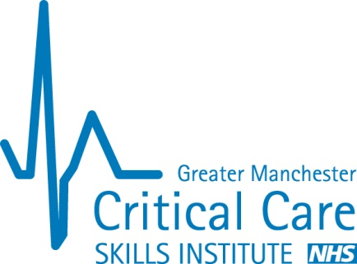
Critical Care Skills Institute
Old St Mary’s Hospital
Hathersage Road
Manchester
M13 0JH

Telephone: 0161 701 7829
Website: www.gmccsi.org.uk

Thank you for your interest in delivering the AIM course within your local setting. Before the AIM Advisory Group (AAG) can sanction your request, we need assurances from your organisation of a realistic implementation plan.

The suggested purpose for delivering the course is to –
a) develop a financially viable and sustainable framework for the ongoing delivery of the course, alongside ongoing quality assurance and course evaluation, and
b) embed the material taught on the course within the clinical culture

The table below provides the structure this plan should follow. Based on the information supplied, the AAG will consider a pricing structure for your organisation, which will cover material and administration costs, and make a small surplus to facilitate review and development of AIM materials for the future.

What to consider | Notes from the AIM Advisory Group | (space for your own notes)
Which course do you want to deliver? | - Adult AIM (for registered nurses)  - CSW AIM (for healthcare assistants)  - Maternal AIM (for maternity units/wards)  - Paediatric AIM (for children’s department/wards)
Who wants the course to be delivered? Has a needs assessment been performed to support this assertion? | The need for Acute Illness training should be recognised within the host institution
Delivery plan  - Who needs the training?  - How many staff will need training?  - How many staff may be trained on each course?  - How frequently will courses need to be delivered? | It is assumed that a cohort of staff has been identified as in need of the training. The delivery plan should identify how this cohort will be trained and how this considers the natural turnover of staff within the identified cohort
Which organisations/departments will be involved in the delivery and receipt of the training? | It is assumed that a core faculty will initially be identified to deliver the course, however there should be a plan to grow this faculty to allow both for natural wastage and to ensure the core faculty do not have to deliver every course
Who will fund the course? Please indicate how the licence fee, training manuals, trainer wages, candidate wages, and other costs will be covered | Whilst the courses are specifically designed to be low cost, they are not free to run. The funding stream to deliver the courses should be identified
Who will take overall responsibility for the delivery, quality assurance, and evaluation of the course? | The courses are not designed as a one-off intervention. Culture change within an institution will only occur when a critical mass of healthcare workers have been trained to approach a deteriorating patient in a similar way. A senior person should take the ongoing responsibility to oversee deliver, quality assurance and evaluation of the course
Do you anticipate the need to modify the course to make it more appropriate for your setting?  How will you assess which changes need to be made?  How will you evaluate the changes? | Educational interventions are most likely to change clinical behaviours if what is taught on the course is achievable in the clinical environment. For this reason, the AIM courses have been modified for the low-income, maternity and paediatric settings. We accept that your specific setting may require further adaptation for your clinical setting
What support will you need from the AIM Advisory Group?

