

**Greater Manchester**

**Critical Care Skills Institute**

**Anatomy & Physiology Workbook**

**Pre-course workbook for Critical Care Programme**

**(reviewed September 2022)**

**Acknowledgements**

The Greater Manchester Critical Care Skills Institute has produced this Anatomy & Physiology Workbook to accompany the completion of the National Competency Framework for Adult Critical Care Nurses Step One competency document. (CC3N, 2013).

The document has been adapted from the core workbooks associated with the Greater Manchester Multi-professional Critical Care Programme, and as such all original contributors are acknowledged by the Critical Care Skills Institute.

The Anatomy & Physiology Workbook has been compiled and reviewed by the Critical Care Skills Institute Practice Educators.

**Aim of the Workbook**

The aim of this Workbook is to assist you in pre-course preparation and on-going learning.

This Workbook should provide underpinning and necessary knowledge for the completion of Step 1 competencies.

It is advisable that you continue to expand on this information using references given.

**Further sources of information List of contents**

Anatomy & Physiology text book The Respiratory System

Practice supervisor/Mentor The Cardiovascular System

Nurse Specialist The Renal System

Pharmacist The Gastro-intestinal System

Anaesthetist Neurological – the Brain and Nervous

Physiotherapist System

Dietician Pain Management

Library Microbiology, Infection Control and

Internet Prevention

**References**

CC3N (Version 2 - 2015) National Competency Framework for Adult Critical Care Nurse Education

**The Respiratory System**

The ***respiratory system*** is responsible for supplying ***oxygen*** to the ***blood***and removing ***waste gases***, primarily carbon dioxide, from the body. The main purpose of the system is to allow the exchange of gases into and out of the blood so that the ***cells***of the body can produce ***energy***for normal cell function. The lungs when unfolded provide a massive surface area of around ***70 square metres*** for gas exchange to take place; they are only 1 cell thick in places (***0.5nm)*** to allow ***diffusion***of gases across the surface. The upper structures of the respiratory system are combined with the sensory organs of smell and taste (in the nasal cavity and the mouth) and the digestive system (from the oral cavity to the pharynx).

In the box below draw a basic line diagram of the main components of the respiratory system.

**Structures of the Respiratory System**

**The Larynx**

The ***larynx*** or voice box is the opening of the ***trachea***where it meets the pharynx. Its protrusion with the ***thyroid cartilage*** can be seen in the exterior of the throat and is commonly called the ‘Adam’s apple’. The larynx also enables vocalisation by manipulating the ***vocal cords*** to vibrate at a desired pitch when air is passed through the larynx. The three cartilaginous structures that comprise the larynx are:

**The Cricoid**

**The Epiglottis**

**The Thyroid**

The circular ***cricoid cartilage*** reinforces the head of the ***trachea***to keep the airway open. The flap-like ***epiglottis***helps to shut off the airway during swallowing as it swings down to meet the upraised larynx to prevent food from entering the ***trachea***. The ***thyroid cartilage*** forms the bulk of the structure of the ***larynx*** anchoring the ***epiglottis*** by means of the false vocal cords and by anchoring the true vocal cords to the glottis.

The pitch of the voice is highly dependent upon the elasticity and tension in these true vocal cords. When the angle of the thyroid cartilage decreases in males during puberty, the tension on the vocal cords diminishes, resulting in a lower voice.

**The Trachea**

The ***trachea*** or windpipe is the upper section of the airway separated from the pharynx by the larynx. It is composed of ribbed cartilage which extends about four inches down to the bronchi of the lungs. Resting against the oesophagus the trachea can extend slightly during swallowing, breathing, or bending the neck. It is lined with a mucous layer and ***cilia***.

**Cilia**

The ***cilia*** are tiny microscopic hairs which protrude from the walls of the cells lining the respiratory tract. These cells are interspersed with goblet cells that produce mucous coating the lining of the respiratory tract.

These hairs help eliminate ***dust*** and ***infectious*** agents from the air that is breathed in before they reach the ***respiratory tract***. The constant ***peristaltic*** action of the cilia carries these particles, trapped in the sticky mucous secretions, to the nasopharynx, where they are swallowed into the stomach or expectorated.

The cilia are also important to the sense of smell. Each hair terminates in a small smell receptor cell known as an ***olfactory receptor***. It is believed that these receptors are sensitive to about 30 primary smells. Other smells are made up of mixtures of some or all of these primary smells. When odorous substances activate the cilia, the receptors respond by firing off a series of nerve impulses to the brain for interpretation.

**The Lungs**

The ***lungs*** are two ***sponge-like sacs;*** they expand with ***diaphragmatic******contraction*** and fill with air. They contain the ***alveoli*** where the diffusion of ***oxygen and carbon dioxide*** occurs.

The ***left lung*** (the body’s left, the viewer’s right) has one horizontal fissure that divides it into ***two lobes*** (upper and lower). The ***right lung*** has one horizontal fissure and one oblique fissure dividing the ***right lung*** into ***three lobes*** (upper, middle and lower). The right lung is larger than the left and extends further down into the abdominal cavity.

The right and left lungs are each enclosed in a ***pleural sac*** and are separated by the ***mediastinum***, a cavity that extends from the vertebral column to the sternum. Each half of the pleural sac is anchored by the ***mediastinum*** and rests on the ***diaphragm*** below.

The medial surface of each half of the ***diaphragm*** contains an opening, called a ***hilus***, through which the ***bronchus, nerves, and blood vessels*** pass.

**The Lungs and Circulation**

***Deoxygenated*** blood is pumped to the lungs from the heart through the ***pulmonary******arteries***. These arteries split and go to each lung, subdividing into ***arterioles*** and ***metarterioles*** deep within the lung tissue. These metarterioles lead to networks of smaller vessels, called ***capillaries***, which pass through the alveolar surface.

The blood diffuses waste ***carbon dioxide*** through the membraneous wall of the ***alveoli*** and takes up ***oxygen*** from the air within. The ***reoxygenated*** blood is then sent to metavenuoles and venuoles, which are tributaries to the ***pulmonary veins***. These veins take the ***reoxygenated*** blood back to the heart to be pumped throughout the body’s arterial system to nourish the cells.

**Pulmonary Pleurae**

The ***pleurae*** of the thorax are the serous membranes, which enclose the ***upper chest cavity***. They are formed of two layers - ***the visceral and parietal pleurae***. The pleurae enclose the lungs and protect them from friction against the wall of the thorax. The parietal pleurae are the ***exterior*** layer of this pulmonary pleural sac which connects to the thorax wall, the mediastinal membrane, and the diaphragm muscle. The visceral pleurae provide an inner layer hugging the entire surface of the lung.

The pleural cavity – a tiny area between the 2 pleural layers, contains a thin film of serous fluid, which performs vital functions to reduce the amount of friction and therefore prevent damage to the lung wall and the thoracic cavity each time the lungs expand and deflate; and to create a bond that causes the lungs to move with the chest wall during breathing.

The two layers also contain a ***slightly negative pressure*** between them, which acts in a way as to “suck” the two linings together. Without this negative pressure, the inner lining of the visceral pleura would detach and the lung would not be pulled outwards to expand. This occurs with a ***pneumothorax***.

In the box below draw a basic line diagram indicating the position of the pleurae in relation to the thoracic wall

**Bronchi and Bronchioles**

The ***bronchi*** are the tubes, which carry air from the trachea to the inner recesses of the lungs, where it transfers oxygen to the blood through small air sacs called ***alveoli***. Two main bronchi, the right and left bronchus, branch off the low end of the trachea in what is called the ***tracheal bifurcation***. One bronchus extends into each of the ***lungs***.

The bronchi continue to divide into smaller passageways called ***bronchioles*** forming a tree-like network of branches that extends throughout the spongy lung tissue. The exterior of the bronchi are composed of cartilaginous, elastic fibre and contain annular reinforcements of smooth muscle tissue. The bronchi are able to distend during inspiration to allow the lungs to expand and contract during expiration as air is exhaled.

The ***bronchioles*** are the intermediate air passages within the lungs. They branch off of the large ***bronchi*** and extend to the smaller branches of the ***alveolar ducts***. The structure of the bronchi, bronchioles, alveolar ducts, and alveoli is often called the “bronchial tree” because its extensive branching resembles the limbs and leaves of a tall deciduous tree.

**Alveoli**

The ***alveoli*** are ‘capillary-swathed sacs’ at the ends of the bronchial tree where gaseous exchange takes place. Each large alveolar sac is like a grape cluster and contains ten or more alveoli.

The membrane separating the ***alveolus*** and the ***capillary network*** is very thin (around ***0.5nm***) and ***semi-permeable***. This enables oxygen to diffuse from the air into the blood cells within the capillaries and carbon dioxide and other waste gases to diffuse out of the blood and into the lungs where they are exhaled.

The ***alveoli*** are made up of several types of cells; some are responsible for the removal of infectious agentsand foreign particles whilst others secrete ***surfactant*** (Type II pneumocytes)***.* *Surfactant*** lowers the surface tension of the alveoli allowing increased ***compliance*** of the lungs, and reduces the amount of effort needed to inflate the lungs on inspiration. Surfactant also plays a role in immune defence.

The ***alveoli*** are particularly susceptible to infection as they provide a warm and moist environment for bacteria and viruses to colonise.

**The Diaphragm and Muscles of Breathing**

The ***diaphragm***is the primary muscle responsible for ***respiration*** and is aided by the ***intercostal*** and ***abdominal*** muscles. The diaphragm is connected to the abdominal wall, the lumbar vertebra, the lower ribs, the sternum, and the pericardium of the heart by tendinous tissue. The thin diaphragm creates a partition between the ***thoracic and abdominal cavity***.

The diaphragm is supplied by the ***inferior and superior phrenic arteries*** and the ***musculophrenic artery***. It is innervated by the ***phrenic nerve***.

The diaphragm forms a ***domed structure*** at rest and when the diaphragm muscle contracts, it lowers to a more flattened arrangement. This flattening creates a negative pressure and a potential space in the thoracic cavity and a positive pressure in the abdominal cavity. This potential space is filled by the expanding lung tissue and inhaled air. The pressure on the lower viscera is helpful in childbirth and in pushing faecal matter through the lower intestinal tract for excretion. When the diaphragm relaxes to its domed structure, the lungs recoil and air is exhaled.

***Inspiration*** is the act of ‘breathing in’ drawing air into the lungs in order to exchange oxygen for carbon dioxide. This is an active process whereas ***expiration*** is normally a passive process. Lungs at maximal inspiration have an average total capacity of 5,500 to 6,000 ml of air.

**Pulmonary Ventilation**

The lungs are involved in the exchange of gases between the atmosphere and the alveoli; the process often referred to as ***pulmonary ventilation*.** This is vital for providing oxygen for the cells to use in the production of energy and the removal of waste carbon dioxide gas.

Describe how the autonomic nervous system monitors and controls our respiration to maintain homeostasis

Briefly explain the term “external respiration”

In the box below, draw the oxygen disassociation curve and explain its clinical significance

**Internal Respiration (cellular)**

This is the stage of respiration in which the oxygen we have been breathing in reaches the cells to produce the energy that gives us life. There are two types of cellular respiration **aerobic** cellular respiration and **anaerobic** cellular respiration. **Aerobic** respiration is a sustainable but complex process of chemical reactions in which oxygen is used to break down glucose into carbon dioxide and water. This releases energy in the form of energy carrying molecules adenosine tri-phosphate (ATP).

Glucose + oxygen carbon dioxide + water + ATP

Internal respiration can occur without oxygen and this is called **anaerobic** respiration. In anaerobic respiration glucose is only partially broken down. Energy is produced, but the process is not sustainable as lactic acid is also produced which can adversely affect homeostasis.

**NB**: The carbon dioxide released during metabolism diffuses out of the cells and into the blood and is removed from the body by the lungs during expiration.

**The Kreb Cycle**

The Kreb citric acid cycle (also known as the tricarboxylic acid cycle) is a series of chemical reactions of central importance to all living cells that utilize oxygen as part of cellular respiration. In these aerobic organisms the citric acid cycle is a metabolic pathway that forms part of the breakdown of carbohydrates, fats and proteins into carbon dioxide and water in order to generate energy.

**Biology of gases**

Analysis of arterial blood gases (ABGs) has become an integral part of the physiological diagnosis and therapeutic treatment of acutely ill patients. ABGs provide information about the patient’s acid base balance, alveolar ventilation, tissue oxygenation and arterial oxygenation. ABG analysis is the measurement of the oxygen (O₂) and carbon dioxide (CO₂) concentrations in the blood and the plasma pH concentration.

Let us now look at an overview of the need for O₂ supply and demand in the body, followed by the behaviour of gases.

We live at the bottom of a sea of air made up of oxygen and nitrogen. By living in air rather than water, we have access to 50% more oxygen. Breathing gives our body access to this sea of air, as it continually exchanges oxygen and carbon dioxide. The amount of oxygen in air remains relatively constant.

In an adult, cells utilise approximately 250mls of oxygen per minute under resting conditions, this may increase by as much as thirty times under strenuous exercise. Metabolic rate may also increase due to infection and disease processes in general. In extreme cases the body may demand more oxygen than the lungs can supply.

The human body can only survive without oxygen for a matter of minutes as brain cells are incapable of functioning without oxygen, problems can occur with oxygen supply when there is failure of the respiratory system, cardiovascular system or both.

The waste product of cellular activity is carbon dioxide with 200ml/minute being produced at rest. A build-up of carbon dioxide in the body is ultimately fatal, the primary function of the respiratory system is to provide adequate oxygen to meet metabolic needs and remove carbon dioxide.

This requires a complex relationship between:

* Ventilation
* Blood perfusion
* The transport of oxygen and carbon dioxide round the body, the nervous system which regulates the rate and depth of breathing to match the physiological needs on a minute to minute basis.

**How does air move?**

The air that we breathe is in constant motion, we experience this motion as “wind” or “breezes”. In reality this motion is molecules of gas moving across and around our bodies. Air is made up of a number of gases and they are subject to a number of physical laws which govern their movement, direction and speed of movement and the number of molecules in any one area at a given time.

Because we are interested in moving air from outside the body to inside the body, we are especially interested in how air moves. Air movement is part governed by Boyles’ Law, which states:

“the volume of a gas varies inversely with pressure, assuming the temperature remains constant”

Whenever a substance exists as a gas, its molecules are free to move about independently. This continuous movement leads to many collisions which in turn exert a certain pressure. Any factor which increases the number of collisions will cause a rise in pressure, for example a rise in temperature will increase the speed in which the molecules travel.

**Dalton’s Law**

Each gas in a mixture exerts its own pressure as if no other gases where present, this partial pressure is denoted by “p”. The total pressure of a mixture of gases e.g. air is calculated by adding all the partial pressures. Atmospheric air is made up of several gases:

Oxygen (O₂) 21%

Nitrogen (N₂) 79%

Carbon Dioxide (CO₂)

Water vapour

Pressure of gases can be measured in either kilopascals (kPa) or millimetres of mercury (mmHg).

Atmospheric pressure = pO₂ + pCO₂ + pN₂ + pH₂O = 101 kPa

For the purpose of this pre-course work book we will use kPa measurements as this is most widely used in clinical practice.

To calculate the partial pressure of oxygen in air:

21% x 101 = 21.2kPa

When a mixture of gases dissolve across a semi-permeable membrane, each gas diffuses from the air where its partial pressure is greatest to the area where its partial pressure is less. Air moves from areas of high pressure to areas of low pressure, this is known as “bulk flow”. For air to move into the lungs the body creates a lower than atmospheric pressure in the lungs by movement of the chest wall and diaphragm, and air moves into the lungs. When air reaches the alveoli, gas diffuses from areas of high pressure to areas of low pressure.

**Henry’s Law:**

The amount of gas that will dissolve in a liquid is proportional to the partial pressure of the gas and its solubility coefficient when the temperature is constant. The ability of a gas to stay in a solution depends upon its partial pressure and its solubility coefficient, i.e. how attracted it is to water.

Solubility coefficient for:

O₂ = 0.024

CO₂ = 0.57

N₂ = 0.012

The solubility coefficient is highest for carbon dioxide and lowest for nitrogen. The higher the partial pressure of a gas over a liquid and the higher the solubility coefficient the more gas will stay in the liquid e.g. CO₂ in lemonade, where gas is in solution in the liquid. As far as the body is concerned, a higher partial pressure of a gas will ensure that a larger quantity of that gas will dissolve.

The pressure gradient for oxygen is 8.5kPa from alveoli to pulmonary capillary and from arteries into tissue capillaries. This is high, but the concentration of oxygen carried in solution is low (distinct from oxygen carried by haemoglobin) because the solubility coefficient is low.

With CO₂ the pressure gradient at the lungs and the tissues is 0.7kPa. With CO₂, the solubility coefficient is much higher, 22 times greater, so that much more CO₂ is carried in solution in the plasma.

Henry’s Law explains two conditions resulting from the change in solubility of nitrogen in body fluids. Although we breathe in 79% nitrogen, it has no effect on body functions because at sea level it has a very low solubility coefficient. But for deep sea divers who breathe under high pressures, the nitrogen solubility coefficient alters. Partial pressure is a function of total pressure and the partial pressure of all the components of a mixture increases as the total pressure increases. As the partial pressure of nitrogen is higher in a mixture of compressed air, a large amount of nitrogen goes into solution in the plasma. Excessive amounts can lead to giddiness and symptoms similar to alcohol intoxication – the so-called “rapture of the depths”.

If a diver is brought to the surface slowly, the dissolved nitrogen is eliminated through the lungs. If he comes up too quickly, the nitrogen comes out of solution too fast and forms gas bubbles in the tissues that lead to decompression sickness. It can be prevented by a slow ascent or the use of a decompression chamber at the surface. The use of helium-oxygen mixtures is used as helium is only about 40% as soluble as nitrogen in blood.

**What are we assessing on an ABG?**

**pH**  = The concentration of H⁺ ions in a solution.

**pCO₂** = The partial pressure of arterial CO₂.

**pO₂**  = The partial pressure of arterial O₂.

**Sodium Bicarbonate (HCO₃)** = The amount of bicarbonate in the plasma (buffering power)

**Base Excess** = The amount of bicarbonate that should be added or subtracted to return an equilibrium

What are the “normal” values of the following?

pH \_\_\_\_\_\_\_\_\_\_\_\_\_\_\_\_

pCO2 \_\_\_\_\_\_\_\_\_\_\_\_\_\_\_\_\_\_\_\_\_\_\_\_\_

pO2 \_\_\_\_\_\_\_\_\_\_\_\_\_\_\_\_\_\_\_\_\_\_\_\_\_

HCO3 \_\_\_\_\_\_\_\_\_\_\_\_\_\_\_\_\_\_\_\_\_\_\_\_\_

Base Excess \_\_\_\_\_\_\_\_\_\_\_\_\_\_\_\_\_\_\_

**Why is the pH of 7.4 normal?**

Need to control the pH of intracellular space

Blood pH must be kept within normal limits

Normal “optimum” pH is necessary for optimal metabolism. Any deviance can cause structural changes to molecules such as enzymes thus causing a disruption to cellular function.

pH is a measure of the number of hydrogen ions in a solution, the scale goes from 0-14.

0 7 14

ACID NEUTRAL ALKALINE

Therefore the normal pH of blood is slightly alkaline.

**Normal physiological control of pH**

Blood pH of 7.4 is required to maintain normal cellular function, this pH is maintained by:

1. **Respiratory System**

The respiratory system responds quickly to changes in pH by either retaining or excreting carbon dioxide (CO₂)

pCO₂ dissolves into carbonic acid in the presence of water:

H₂O + CO₂ ↔ H₂CO₃

In acidosis the lungs will “blow off” acidic CO₂ by hyperventilation.

In alkalosis the lungs will retain CO₂ by hypoventilation

1. **Renal/Metabolic system**

The kidneys can respond to imbalances by eliminating or retaining H⁺ or HCO₃ in the urine.

In acidosis they will eliminate H⁺ and retain HCO₃

In alkalosis they will eliminate HCO₃ and retain H⁺.

1. **Buffering systems**

Buffers act like chemical sponges either soaking up or releasing H⁺

There are 3 main buffers: Bicarbonate

Haemoglobin and other proteins

Inorganic phosphates and other buffers

The pH of the body can be maintained by compensation or correction by medical treatment.

**Compensation**

The system not primarily affected is responsible for returning pH towards normal.

Compensation may be partial or complete, in partial compensation there is a response from other systems to correct the primary disorder but not sufficient to return the pH to normal. In complete compensation there is a primary disorder but the pH has been fully corrected by the other systems.

Compensation may be rapid or slower. When the lungs compensate for non-respiratory abnormality, compensation can occur within hours. When the renal system compensates for a respiratory abnormality compensation can take 2 – 4 days.

Medical treatment is aimed at **correction.**

**Bicarbonate (HCO₃)**

Actual bicarbonate is affected by both metabolic and respiratory processes so therefore the measurement is standardised to record the amount of bicarbonate that would be present in a blood sample if pCO₂ = 5.3kPa, temperature = 38°C, blood would be fully oxygenated at sea level. Bicarbonate is a base solution regulated mainly by the kidneys.

**Base Excess/Deficit**

Used for calculating the amount of bicarbonate required to correct a metabolic acidosis.

**Bicarbonate and base excess are influenced only by non-respiratory causes i.e. metabolic disturbances.**

**Summary of Gas Exchange and Gas Transport**

***In the pulmonary capillary***

O₂ diffuses from the alveolus (area of high pO₂) to the pulmonary capillary (low paO₂). O₂ combines with haemoglobin in the erythrocytes, which is transported to the tissue capillary:

O₂ + Hb → HbO₂

***In the tissue capillary***

O₂ is released from haemoglobin:

HbO₂ → Hb + O₂

O₂ diffuses from the capillary (high pa0₂) into the cell.

***In the cell***

O₂ and nutritive substances are transformed into energy which can be used by the cell:

Nutritive substance + O₂ oxidation → Energy + CO₂ + H₂O

The result is water and a high pCO₂.

***In the tissue capillary***

CO₂ diffuses into the blood (area of low paCO₂).

Water and CO₂ combine within the erythrocytes and are then divided up into hydrogen ions and bicarbonate ions:

CO₂ + H₂O → H₂CO₃ → HCO₃ + H⁺

The hydrogen ions combine with haemoglobin, the bicarbonate ions diffuse out into the plasma:

H⁺ + Hb → HHb

CO₂ is also transported bound to protein in haemoglobin and physically in solution in the plasma.

***In the pulmonary capillary***

Haemoglobin releases the hydrogen ions which diffuse into the plasma:

HHb → H⁺ + Hb

The hydrogen ions combine with the bicarbonate ions in the plasma and then divide up into water and CO₂

H⁺ + HCO₃ → H₂CO₃ → H₂O + CO₂

CO₂ diffuses from the plasma (high paCO₂) into the alveolus (low paCO₂).

**Carbon Dioxide Transport**

An arterial venous difference in the CO₂ content of the blood is responsible for the transfer of CO₂ from the tissues to the respiratory surface. Most of the CO₂ in the blood is combined with H₂O to make bicarbonate ions. Carbonic acid is made but this quickly dissociates.

Carbonic Acid

CO₂ + H₂O ↔ H₂CO₃ ↔ H⁺ + HCO₃

In the body acid is made via metabolism and via food. Alkali is ingested and equilibrium is maintained.

CO₂ and hydrogen ions stimulate breathing rate and depth.

Chemoreceptors present in the aorta and the carotid arteries are very sensitive to changes in CO₂, H⁺ and O₂. These stimulate the respiratory centre in the medulla oblongata in the brain.

A high CO₂ or H⁺ causes an increase in respiratory rate and vice versa.

**How the cell rids CO₂**

Red Blood Cell

HHB

PLASMA

**Normal Physiological Detection Systems**

Changes in arterial pCO₂ and pO₂ are detected by:

**Central chemoreceptors**

Found in the medulla

Most responsive to increases in arterial pCO₂

CO₂ diffuses into CSF where it becomes hydrated and forms carbonic acid

Receptors detect a decrease in pH of CSF

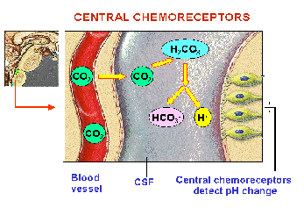

**Peripheral chemoreceptors**

Found in the aorta and carotid arteries

Most responsive to decreased arterial pO₂

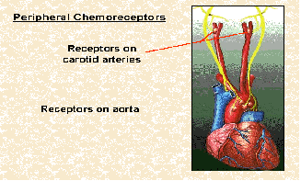

**Disorders of acid-base balance**

Changes in acid-base balance are reflected in the pH of arterial blood. It is important to ascertain the reason behind the change.

With respiratory disorders CO₂ excretion via the lungs is either too little or too great (alveolar hypo or hyperventilation) relative to the bodies CO₂ production.

With the metabolic acid-base disorders, there is an imbalance between the body’s production and elimination of non-respiratory acids.

Test yourself!

**Interpret the following arterial blood gas results:**

1. pH = 7.21

pCO₂ = 9.5 kPa

pO₂ = 11 kPa

HCO₃ = 23 mmol/1

BE = +2

Answer:

2. pH = 7.55

pCO₂ = 2.8 kPa

pO₂ = 14 kPa

HCO₃ = 24 mmol/1

BE = 0

Answer:

3. pH = 7.13

pCO₂ = 3.4 kPa

pO₂ = 12 kPa

HCO₃ = 16 mmols/1

BE = - 10

Answer:

4. pH = 7.50

pCO₂ = 5.0 kPa

pO₂ = 15 kPa

HCO₃ = 30 mmols/1

BE = +5 mmols/1

Answer:

**Ventilation / Perfusion (V/Q) Relationships**

Ventilation and perfusion are not uniformly distributed throughout the lung but are normally well matched, mismatching normally results in inefficient gas exchange.

In the box below define the following terms:

Shunt:

Dead space:

V/Q mismatch:

**The Respiratory System - References**

Dougherty L and Lister S (2011) The Royal Marsden Hospital of Clinical Nursing Procedures: Eighth Edition. Blackwell Publishing.

Greater Manchester Critical Care Network (2014) Acute Illness Management : Fifth Edition Manchester, Greater Manchester Critical Care Network.

Resuscitation Council (UK) 2004Advanced Life Support Course Manual (4th edition) London: Resuscitation Council UK

Woodrow, P. (2000). Intensive Care Nursing, A Framework for Practice London, Routledge

**ARTERIAL BLOOD GAS ANALYSIS – Open Learning Workshop Preparation Pack. By,** Kathryn Alletson, RGN, DPSN, ENB 100, 998, 920, 923, R34, Sister, ICU, Birch Hill Hospital; Annette Moriarty, RGN, DPSN. ENB 100, 998, ACLS, Sister, ICU, Bury General Hospital; Steve Thomasson, RGN, DPSN, ENB 100, 998, Charge Nurse, ICU, Hope Hospital. Edited by Andrew Clough & designed & compiled by Susan Barr, Project Administrator.

**The Cardiovascular System**

Label the following picture



Which major blood vessel is missing from this picture?

Answer:

Define an artery:

Define a vein:

What are the differences between arteries and veins?

Describe the blood flow through the heart:

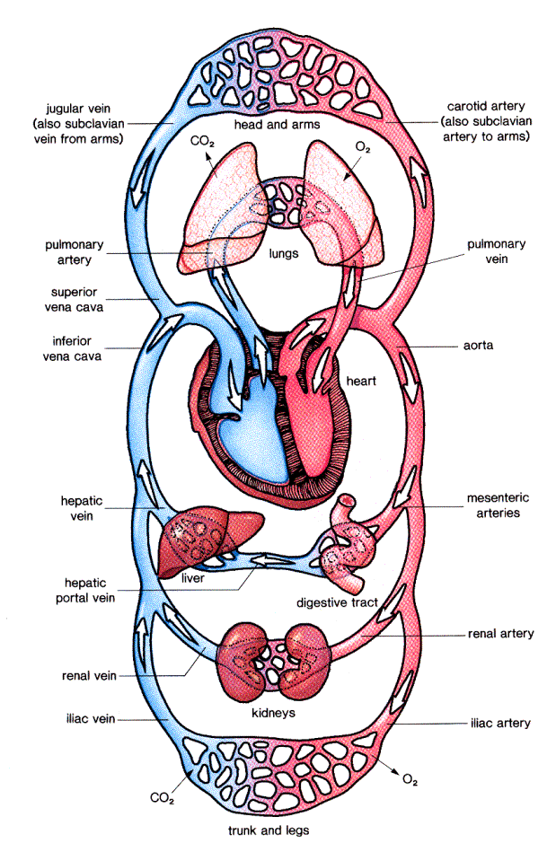

Review the blood vessels which enter and leave each organ

TutorVista.com (2014)



**The Electrical Conducting System**

**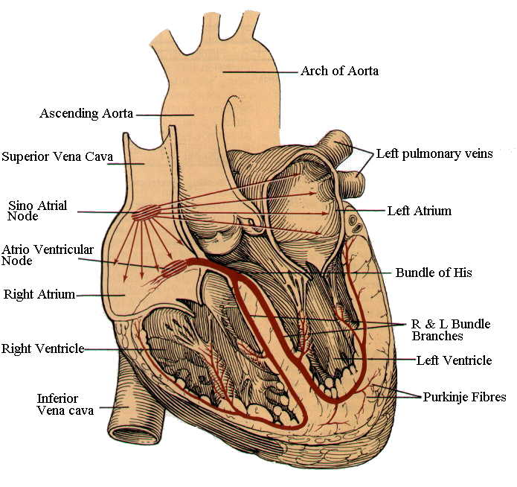**

Tortora (2017)

**The location of the conduction system in the heart**

The heart is typically described as a ‘blunt inverted cone’, the size of the owner’s fist. This means that impulses, triggered from the Sino Atrial (SA) node, travel from the base down to the apex. This is so the impulses travel back up the ventricular walls via the purkinje fibres, causing the heart to depolarise towards the valves at the top of the chamber – so maximising output (if depolarisation only occurred from the base, the contraction wave would squeeze the blood in the wrong direction – which can occur with premature contractions).

The left ventricle (LV) is larger in volume and muscle mass than the right ventricle (RV) and the conductive system is more extensive. The Left Bundle Branch splits into two branches known as the Anterior and Posterior Fascicles allowing impulses to be spread more quickly through the muscle mass.

We can diagrammatically represent the conduction system for ease of use

**A diagrammatic representation of the conductive system**

**The SA Node** is known as the heart’s primary pacemaker.

It is a collection of cells situated near the junction of the Superior Vena Cava (SVC) with the Right Atrium (RA).

It receives its instructions from the sympathetic & parasympathetic (Vagus Nerve) systems depending on the demands placed on the heart by the needs of the body. Its Intrinsic Discharge Rate (IDR) is approximately 75 beats per minute (bpm).

**The Inter Nodal Pathways** are recognized as;

The Thoral Tracts

The Bachman Tracts

The Wenkebach Tracts

These are the tracts believed to run between the SA node and the Atrio Ventricular (AV) Node, although there is no physical evidence of their existence.

**The AV Node** is a collection of cells which lies at the junction of the right atrium with the ventricular septum. It is described as a ‘Latent Pacemaker’ and its IDR is approximately 60 bpm.

**The Bundle of His** is the continuity of the AV node through the fibrous ring separating the atria and the ventricles. Impulses are ‘delayed’ by 0.10 sec to allow ventricular filling to be completed by the atria.

**The Right Bundle Branch & Fascicles** travel down into the ventricles. The anterior fascicle supplies the anterior & superior LV, whilst the posterior fascicle supplies the inferior & posterior LV.

**The Purkinje Fibres** or the terminating fibres of the conduction system enclose the whole of the ventricular muscle, creating a closed network of conduction.

**Why do we need such an elaborate conduction system?**

The conduction system can be viewed as a ‘motorway network’ for electrical impulses. Skeletal muscle and cardiac muscle (myocardium) differ in many ways. The myocardium has the ability to continuously contract and relax, any electrical impulse will travel across the myocardium, causing global contraction. This is termed ‘electrical bridging’.

‘Electrical bridging’ of myocardium

If we solely relied upon this mechanism, contraction would be slow & ineffectual. To get from A to B it is quicker to go via the motorway! If the ‘motorway’ conduction system is damaged, impulses can still get through via the ‘country lanes’ but it will take longer. Our ECG would indicate that a delay was occurring (as in bundle branch block) and we would see an additional (delta) wave lengthening the QRS time interval.

How & why does electrical activity occur?

Electrical activity is produced by the movement of electrolytes across a semi permeable membrane, this is called ‘**saltatory conduction’.**  Electrical activity is then generated and transmitted by the same method, creating a domino effect across the myocardium – similar to a ‘mexican wave’.

Saltatory conduction

Cells have the ability to pump sodium (Na+) out across their semi permeable membrane and into the plasma; the so called ‘sodium pump’. Na+ is a positively charged particle and as the level of the positively charged electrolytes accumulates, other positively charged electrolytes, e.g. K+, Mg++, Ca++, are ‘pushed’ in the opposite direction (a bit like trying to put two North poles of 2 bar magnets together; they repel one another). This means that blood levels of Na+ will be high, whilst the levels of other positively charged electrolytes will be low. We know this is true just by examining normal blood levels:

Na+ = 136 – 142 mmol/L

K+ = 3.8 – 5 mmol/L

Ca++ = 4.6 – 5 mmol/L

Mg++ = 1.3 – 2.1 mmol/L

Without the sodium pump there would be the same concentration on either side of the semi permeable membrane. The Na+ pump maintains this disequilibrium and an electrical potential is said to exist - **‘the resting potential’**. However, at this stage there is no electrical activity and the ECG is a flat line (0 volts, the isoelectric part of the ECG).

**‘Resting Potential’**

Sodium pump

Na+

**Na+**

**K+**

K+

**Mg++**

Mg++

**Ca++**

Ca++

Capillary

Myocardial cells

0 volts

Cells at resting potential

Isoelectrical part of ECG

When an electrical impulse from the SA node hits the cells , the Na+ pump stops working and the electrolytes, with nothing to ‘keep them in place’ change position across the membrane trying to equalise themselves on either side of the membrane, thus an electrical current is produced, spreading to the next cell and the next cell etc. The cells are ‘depolarised’ or ‘discharged’ creating the **‘action potential’** forming the PQRS.

**‘Action Potential’ (Depolarisation)**

Electrolytes change position. Electrical charge has been released

Electrical Impulse

**Na+**

Na+

K+

**K+**

Mg++

**Mg++**

Ca++

**Ca++**

Capillary

Myocardial cells

0.4m volts

Cells at action potential PQRS complex

Sodium Pump stops

Once discharged repolarisation needs to occur, before depolarisation can recommence. As soon as the impulse moves on the Na+ pump re starts and the electrolytes return to their original positions, the electrical potential is thus restored. Ventricular repolarisation is represented on the ECG by the T wave.

**‘Repolarisation’**

With the electrical activity having progressed from one cell to another, the sodium pump can now get back to work. ‘Repolarisation’ of the cells

Sodium pump

Na+

**Na+**

**K+**

K+

**Mg++**

Mg++

**Ca++**

Ca++

Capillary

Myocardial cells

The repolarisation part of the ECG ‘T’ wave

This electrical activity generated is very small and is measured in millionths of a volt (mV), but can be amplified and displayed as an ECG.

Adequate electrolyte levels are essential for correct functioning of the myocardium. K+ is particularly important

hypokalaemia will increase the electrical potential which could lead to premature contractions;

hyperkalaemia will reduce the electrical potential – ultimately leading to asystole.

Spurious electrical activity or ectopic activity occurs if the myocardium has experienced an insult causing inflammatory changes. Mechanical, electrolytic, or hypoxia insults allow water and electrolytes to move from an area of high concentration to an area of low concentration, creating abnormal activity in the myocardium.

**The basic ECG waveform**

The ECG waveform was first discovered in 1903 by Einthoven who named the 3 recognisable deflections.



P wave

QRS complex

T wave

**P wave**

Represents the conduction of electrical activity through the atrial myocardium. It is normally small, rounded and precedes the QRS complex.



The P-R interval is normally 0.12 – 0.2sec. (3 – 5 small squares)

**QRS complex**

Represents the conduction of electrical activity through the ventricular myocardium – as this is much larger than the atrial myocardium, the deflection is usually bigger.

It is also normally spiky, with normal time intervals of: - Q = 0.04sec (1 small square)

QRS interval = <0.12sec (3 small squares)

**T wave**

This represents the repolarisation phase of the ECG. Normally the wave should begin from the isoelectric baseline. If not, ischaemic changes are indicated. If the wave is incomplete or affected by any other wave or electrical activity, disruption may occur i.e life threatening arrhythmias. In young people and some ethnic groups the T wave is sometimes normally inverted

**U wave**

The U wave is normally not visible or apparent but is part of the ‘normal’ complex. It is part of the repolarisation phase and is a small rounded positive deflection – the precise origin of which is not fully understood.

One of the most important end functions of the systemic circulation is to deliver oxygen (O2) to cells. Patients with heart failure, fluid overload, shock, pulmonary hypertension, and other such problems have altered haemodynamic status.

**Physiological control of the cardiovascular system**

**What is blood pressure (BP)?**

Using a text book, find a **written** definition of blood pressure and note it below:

We are all familiar with the systolic and diastolic components of blood pressure; we are less familiar with Mean Arterial Pressure (MAP). In the box below write a definition of MAP

In caring for the critically ill patient we need to understand how and why BP is maintained and controlled, and the anatomical structures involved. In the box below, list the three structures that make up the cardiovascular system

The blood transports nutrients, oxygen, hormones etc to the tissues and removes waste products such as carbon dioxide (CO2). To achieve transportation we need a pump, tubes & fluid. Haemodynamics is the study of how well the pump, tubes and fluid are functioning as regards the transport, principally of O2. The heart is the pump, the blood vessels are the tubes and the fluid is the blood.

|  |  |  |
| --- | --- | --- |
| Blood | Heart | Vessels |
| [220px-Blausen_0086_Blood_Bag](http://en.wikipedia.org/wiki/File:Blausen_0086_Blood_Bag.png) | Heart-Blending | Capillary_system_CERT |

**Components of blood pressure**

Stroke volume (SV) = the amount of blood ejected from the ventricles in each contraction

Cardiac output (CO) = the amount of blood ejected from the ventricles in one minute.

Systemic vascular resistance (SVR) = the force of the ventricle ejection against the impedence of the arterial vessels.

The Heart Rate (HR) and the stroke volume force blood into the circulation and together create the Cardiac Output (measured in L/min).

However, CO is only a component of blood pressure. The CO flows through blood vessels and depending upon the ‘tone’ of the blood vessels (how constricted or dilated they are) a blood pressure, will be generated.

As an equation blood pressure is:

**BP = CO (HR x SV) x Systemic Vascular Resistance (SVR)**

We thus have **three components of blood pressure**, **HR, SV and SVR**.

Each of these three components of blood pressure relates to the structures of the cardiovascular system. Which component relates to which structure?

Blood \_\_\_\_

Heart \_\_\_\_

Vessels \_\_\_\_

These factors that govern cardiovascular efficiency are also termed:

**Pre load**

**Contractility**

**After load**

From your text book, give a definition of these terms

Preload:

Contractility:

Afterload:

Each of these three factors also relates to the structures of the cardiovascular system. Which factor relates to which structure?

Blood Heart Vessels

Stroke Volume Heart rate Systemic vascular resistance

If any of these components are altered then the body can respond by altering the other component(s), thus compensation is said to occur. These ‘compensation’ mechanisms occur to some degree, all the time to maintain homeostasis. In extreme circumstances, for example when circulating volume is lost following bleeding, there will initially be a reduction in stroke volume. This will cause a ‘rebound’ tachycardia to occur, in an effort to maintain CO at the ‘normal’ level. This is the reason why specific parameters are monitored post-op. An elevated HR may thus indicate that post-op bleeding is occurring, but an increase in respiratory rate, is an earlier sign of deterioration as the body is trying to get more oxygen into the available blood, (blood loss = loss of oxygen carrying capacity). But, as we shall see, when we examine shock more closely, these compensation mechanisms can be ‘self-destructive’, rather than helpful.

Find a definition of Frank Starling’s Law

Frank Starling’s Law:

**Physiological control of blood pressure**

Neurological control of blood pressure is under the influence of the vaso motor centre and cardio regulatory centre of the brain via the sympathetic and parasympathetic nervous system .

**Pressure receptors**

**Baroreceptors** in the right atrium, aortic arch & carotid arteries detect changes in pressure.

**Chemoreceptors** in the aortic arch & carotid arteries detect chemical changes in pH, CO2 and O2

Both feed back information to the Pons and Medulla Oblongata, in the brain, which appropriately stimulate the required organ(s), i.e. heart, lungs and vasculature.

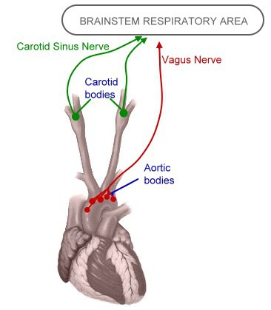 Quizlet.com

**Nervous control**

**Heart Rate**

As previously mentionedthe SA & AV nodes are well innervated by sympathetic and parasympathetic nerve fibres. Control of these autonomic nerves is via the cardiac centre in the medulla oblongata in the brain.

* Sympathetic nerve discharge to the SA node have a +ve chronotropic effect increasing the heart rate
* Parasympathetic - vagal stimulation from the vagus nerve, mediated by acetylcholine have a -ve chronotropic effect. Main effect is to the AV node, slowing conduction and heart rate

Circulating catecholamines, e.g. adrenaline/noradrenaline affect the intrinsic heart rate, +ve chrontropic effect increasing the heart rate.

Circulating catecholamines also affect the SA node, +ve chronotropic effect.

**Stroke Volume**

Sympathetic nerve activity – from noradrenaline release, causes the myocardial muscle fibres to shorten even more (the ‘inotropic’ state of the heart), increasing global contractility and thus stroke volume. Parasympathetic activity has the opposite effect.

General sympathetic activity also causes catecholamine release from intramyocardial catecholamine stores.

Sympathetic discharge enhances ventricular synchronicity because electrical impulses are better transmitted through the AV node and conductive system.

**Systemic Vascular Resistance (SVR)**

Baroreceptors in

* Aortic arch (Vagus)
* Common carotid

They communicate with the vaso-motor and cardiac centres, within the medulla and pons in the brain.

The size (internal diameter) of the blood vessels depends on sympathetic activity (adrenergic pathways - i.e. noradrenaline regulated by the vaso-motor centre (VMC).

*Hypotension* will cause an increase in VMC activity, i.e. vasoconstrict.

*Hypertension* will cause a decrease in VMC activity, i.e. vasodilate.

Parasympathetic activity (cholinergic pathways, e.g. acetylcholine) has a "damping down" effect on the VMC.

**Hormonal Control**

**Aldosterone**

Aldosterone is a hormone secreted by the adrenal cortex. It exerts an effect on the secretion of sodium by the kidney.

When secreted, aldosterone increases the activity of the 'sodium pump' and thus causes sodium to be absorbed from the urine forming in the distal tubule into the bloodstream.

In the absence of aldosterone considerable amounts of sodium are lost in the urine.

The secretion of aldosterone is stimulated by a fall in the sodium concentration of the blood.

This change is detected by receptors in the kidney. These receptors, the **juxtaglomerular** **apparatus** are situated at the point where the distal convoluted tubule comes close to the glomerular supply artery (the efferent arteriole).

The juxtaglomerular apparatus release a substance, **Renin**, which combines with angiotensinogen and is converted in the blood stream into a substance called Angiotensin 1. Angiotensin 1 is converted in the lungs into angiotensin 2 (via ACE). It acts on the adrenal cortex to cause the secretion of aldosterone.

**Angiotensin II** is also a potent vasoconstrictor. Thus, if circulating volume is reduced, the kidney, which normally uses about 25% of cardiac output to produce urine, is not only able to conserve fluid but can reduce the circulating volume space to maintain a ‘normal’ BP.

**Anti-Diuretic Hormone (ADH)**

ADH is secreted in response to the circulating volume. If there is any sign of hypovolaemia then the ADH cycle is triggered. As the term implies ADH stops diuresis.

In cases of diabetes insipidus when there is excessive diuresis, the ADH mechanism has been damaged. ADH is also known as vasopressin, and a synthetic analogue (DDAVP) is given in patients with this condition.

This is often seen in patients with head injuries.

**The ADH cycle**



**Fluid Management**

Fluid composes 45-75% of the body weight.

Fluid balance is homeostasis of total body water. When a body is in homeostasis this means that it contains the required amount of fluid and that this fluid is distributed to the various compartments according to their needs. Fluid management should take into account total body hydration and effects all three compartments.

In the box below, name the fluid compartments of the body and state how the fluid is divided between the compartments

Management is vitally important to maintain normal cellular function and, in the case of the plasma volume, to optimize stroke volume and cardiac function.

**Osmosis** is the primary way in which water moves in and out of the body compartments.

In the box below explain the process of osmosis

**Fluids and Electrolytes**

To understand how fluids are regulated in the body we must look at the impact of electrolytes.

In the box below define what electrolytes are and list the main electrolytes found in the body

Body fluids contain electrolytes and non-electrolytes. 95% of solute molecules are dissolved in body water. Some are found in the Extracellular fluid (ECF) and some in the Intracellular Fluid (ICF).

In the box below write in your own words the main functions of Sodium andPotassium

Sodium:

Potassium:

Nutrient materials pass into the tissue fluid by the process of diffusion, in the box below explain the process of diffusion

**Tissue fluid formation**

The capillary networks are permeable in order for oxygen, water, nutrients, hormones, enzymes and electrolytes to bath the cells (interstitial fluid) and be selectively up-taken by the cells, and waste products to be removed.

On the ‘arterial end’, the plasma is under pressure because of the blood pressure, this squeezing effect is known as the ‘blood hydrostatic pressure’. This of course squeezes fluid containing nutrients through the pores in the capillaries – a bit like squeezing a tea bag in your hand. Normally, red cells and plasma proteins are too big to pass and so stay in the plasma (although ‘micro albumin’ can pass through). The cells and interstitial fluid will also exert osmotic pressure upon the plasma – there is normally no perceivable interstitial fluid hydrostatic pressure.

On the venous end of the capillary network plasma proteins exert an osmotic pulling pressure on the interstitial and intracellular fluid. Because blood hydrostatic pressure is less, the net effect is that fluid is pulled back into the plasma – with some also being absorbed via the lymphatic system. Note the diagram below but remember this is a ‘dynamic’ process.

Tissue fluid formation

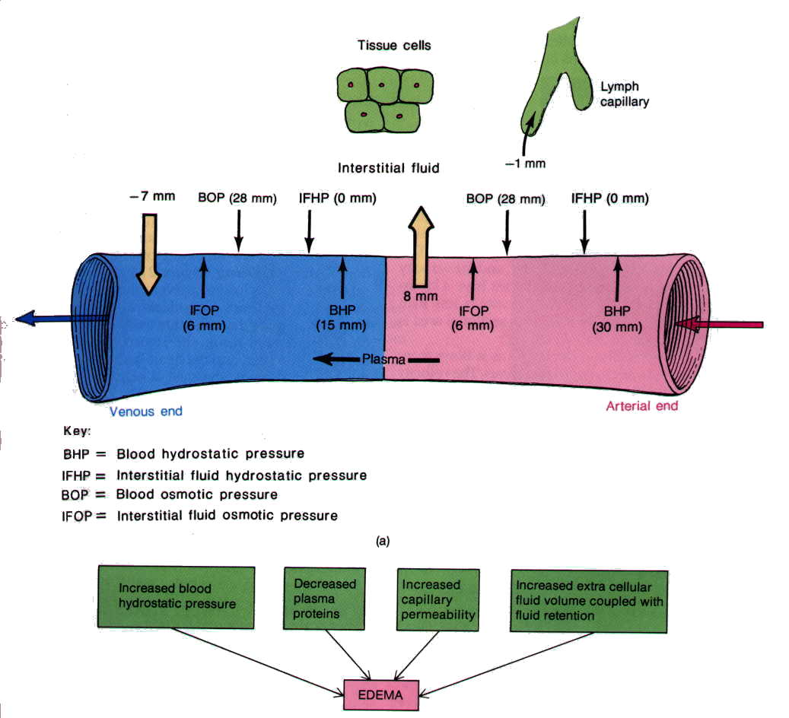

Tortora (2017)

The green boxes indicate how normal tissue fluid formation can become disordered in the critically ill patient. Haemodynamic instability, hypoxia at tissue level, and production of lactate results in a metabolic acidosis which alters capillary permeability – as seen in shock. Infection, sepsis and Disseminated Intravascular Coagulation (DIC) can also do this. If these conditions are then compounded with malnutrition, and a consequential reduction in plasma protein – it can be easily seen that the critically ill patient is at risk of oedema. If this oedema is present within major organs, they will not function as normal – frequently causing pulmonary function to deteriorate as seen in the shocked patient.

**Shock**

The shocked patient is often, (but not always) grey, cool, sweaty, tachycardiac, hypotensive, oliguric, but how can we define it physiologically?

‘**Shock can be defined as “a failure of the cardiovascular system to deliver sufficient oxygen and nutrients to meet cellular metabolic needs”**

Tortora (2017)

Oxygen delivery can be expressed as DO2. The most common types of shock seen are those when the total delivery of oxygen is reduced. Common causes are haemorrhage, hypovolaemia, myocardial infarction (MI) and/or Left Ventricular Failure (LVF).

Now we understand the components of BP = **HR x SV (CO) x SVR**, we can relate these to the signs and symptoms presented. Reduction in circulating volume will have reduced cardiac output, and hence reduced oxygen delivery. The baro and chemoreceptors will detect this, causing the cardiac and respiratory centres to respond. The respiratory and heart rate increases in an effort to maintain the cardiac output.

Reduced CO and reduced BP will stimulate the juxtaglomerular apparatus in the kidneys to begin the renin-angiotensin cycle, producing aldosterone and vasopressin. This increases vascular resistance and conserves water. Osmoreceptors in the hypothalamus are also stimulated to produce ADH, and conserve water. As vasoconstriction begins, blood flow to the periphery is diminished.

Patients will therefore display all the signs of shock. The compensation mechanisms have acted to maintain oxygen delivery to vital organs. Early detection means simple measures can be taken, rather than crisis management steps.

There are a number of classifications of shock, list them in the box below

**Hypovolaemic shock**

Causes often involve haemorrhage, surgery, trauma, poor hydration, high insensible loss, diarrhoea, vomiting and burns.

Signs & symptoms

* Pale
* Cool
* Clammy
* HR elevated
* BP reduced
* CVP down (If in ICU, PCWP down)
* Oliguria

How does hypovolaemic shock affect the components of the BP equation?

BP = SV x HR x SVR

(CO)

**NOTE: Obstructive shock** is a term associated with physical obstruction of the [great vessels](http://en.wikipedia.org/wiki/Great_vessels) or the [heart](http://en.wikipedia.org/wiki/Heart) itself. [Pulmonary embolism](http://en.wikipedia.org/wiki/Pulmonary_embolism) and [cardiac tamponade](http://en.wikipedia.org/wiki/Cardiac_tamponade) are considered forms of obstructive shock.

Obstructive shock has much in common with [cardiogenic shock](http://en.wikipedia.org/wiki/Cardiogenic_shock), and the two are frequently grouped together.

Some sources do not recognize obstructive shock as a distinct category, and categorize [pulmonary embolism](http://en.wikipedia.org/wiki/Pulmonary_embolism) and [cardiac tamponade](http://en.wikipedia.org/wiki/Cardiac_tamponade) under cardiogenic shock.

**Cardiogenic shock**

Cardiogenic shock is caused by impaired cardiac performance; common causes are left ventricular failure (LVF), myocardial infarction (MI), and cardiac tamponade.

Signs & symptoms

* Pale
* Cool
* Clammy
* HR elevated
* BP reduced
* CVP increased (If in ICU, PCWP increased)
* Oliguria

How does cardiogenic shock affect the components of the BP equation?

BP = SV x HR x SVR

(CO)

The first affected is the stroke volume (HR will also be affected if MI is the cause, as this affects the conductive pathways). As in hypovolaemic shock, the reduction in CO (and BP) leads to an increase in SVR. However, in cardiogenic shock CVP rises as the heart fails in its ability to pump the available volume into the systemic circulation, this creates back flow through the lungs and into the right side of the heart.

In cardiogenic shock the compensation occurring to try and maintain a ‘normal’ BP quickly becomes ‘self destructive’. As the SVR rises, the heart has to work harder in order to pump against an increased resistance (SVR). This results in a vicious cycle of increasing SVR, decreasing CO, and hence a fall in BP. The falling CO impairs tissue oxygen delivery, resulting in anaerobic metabolism and production of Lactate. As the heart rate increases the coronary arteries are not perfused adequately and further myocardial insult occurs.

**Septic Shock**

Septic shock is as prevalent as hypovolaemic and cardiogenic shock, but poorly recognised, diagnosed and treated. However, the surviving sepsis campaign (SSC 2016) has addressed this problem, and the implementation of early goal directed therapy has improved recognition, diagnosis and treatment. Haemodynamic parameters present differently, but the end result is the same, a reduction in oxygen supply to the tissues. Septic shock is very complex, and can only be discussed briefly in this workbook. There have been several classifications of terms to define Septic Shock, more recently Singer et al (2016) recommended the use of the terms **sepsis** and **septic shock**.

Septic shock follows a continuum. Define the following terms

SIRS:

Sepsis:

Severe sepsis:

Septic shock:

MODS:

Signs & symptoms

* Temp. >38.5 oC , flushed, OR <36 oC
* Heart rate >90bpm, full and bounding
* Tachypnoeic (RR >20)
* WCC<4 or >12 (x109/l)
* Acutely altered mental state
* Hyperglycaemia in the absence of diabetes
* History or signs of an infection
* Signs of organ dysfunction

How does septic shock affect the components of the BP equation?

BP = SV x HR x SVR

(CO)

In septic shock the SVR falls due to vasodilation, and the HR and SV increases to overcome the fall in resistance. However, an increase in CO is insufficient to compensate for the loss of SVR and BP falls as a result. Again, tissues have reduced oxygen supply so will metabolise anaerobically, producing lactic acid as a by-product.

**Anaphylactic shock**

Anaphylaxis is a sudden reduction in BP caused by an allergic reaction – the patient can collapse very quickly and suffer cardiac and/or respiratory arrest.

Following initial exposure to something (e.g. Penicillin, peanuts, prawns) antibody formation occurs. Upon second exposure an inappropriate systemic allergic reaction occurs, releasing ‘massive’ amounts of histamine. This results in a sudden drop in SVR and constriction of the pulmonary bronchioles.

Signs & symptoms

* Flushed appearance, warm to touch
* Patient may complain of palpitations, difficulty breathing/wheeze
* Feeling of ‘impending doom’
* BP reduced
* Sudden collapse

How does anaphylaxis affect the components of the BP equation?

BP = SV x HR x SVR

(CO)

**Neurogenic shock**

Neurogenic shock is usually as a result of spinal cord injury. It occurs when there is a cessation of sympathetic nervous control over the vasculature, causing vasodilation, and a reduction of SVR. Treatment includes the use of vasopressor therapy to restore SVR, however the condition is very rare.

**NOTE:** **Distributive Shock** is a term associated with excessive vasodilation and the impaired distribution of blood flow such as Septic, Anaphylactic and Neurogenic shock.

**The Cardiovascular System - References and Bibliography**

Bartlett, R H (2010) *Critical Care Physiology,*University of Michigan University Library: The Scholarly Publishing Office

Hampton J. (2019) *The ECG Made Easy,* 9th Edition, London: Churchill Livingstone

NICE Guidelines 51 (2017) Sepsis: recognition, diagnosis and early management

<http://www.nice.org.uk/guidance/ng51> [online] [accessed 2nd February 2020]

Surviving Sepsis Campaign (2016) *Surviving sepsis campaign responds to sepsis-3* – Surviving Sepsis Campaign [online] [accessed 16th June 2016]

<http://www.survivingsepsis.org/SiteCollectionDocuments/SSC-Statements-Sepsis-Definitions-3-2016.pdf>

Surviving Sepsis Campaign (2012) *International Guidelines for Management of Severe Sepsis and Septic Shock: 2012,*Surviving Sepsis Campaign

<http://www.survivingsepsis.org/guidelines/Pages/default.aspx>

Singer, M., Deutschman, C.S., Seymour, C.W., Shankar-Hari, M., Annane, D., Bauer, M., Bellomo, R., Bernard, G.R., Chiche, J.D., Coopersmith, C.M., Hotchkiss, R.S., Levy, M.M., Marshall, J.C., Martin, G.S., Opal, S.M., Rubenfeld, G.D., van der Poll, T., Vincent, J.L., Angus, D.C., 2016. The Third International Consensus Definitions for Sepsis and Septic Shock (Sepsis-3). *JAMA* 315, 801. Doi:10.1001/jama.2016.0287

Tortora, G.J. (2017) *Principles of anatomy and physiology,*15th ed. Hoboken, NJ: John Wiley and Sons

The Sepsis Manual (2019) 5th Edition. United Kingdom Sepsis Trust

<https://sepsistrust.org/wp-content/uploads/2020/01/5th-Edition-manual-080120.pdf> [online] [accessed 14th February 2020]

TutorVista (2014) *Diagram of human circulation,* <http://www.tutorvista.com/content/biology/biology-iv/circulation-mammalian-heart.php>

Quizlet (2014) Where are peripheral chemoreceptors located? –image [online] [accessed 17th December 2014]

<http://quizlet.com/17247151/final-exam-review-2-flash-cards/>

.

**The Renal System**

**Introduction**

Body cells produce nitrogenous waste products such as urea, creatinine and ammonia, which must be removed from the blood before they accumulate to toxic levels. Ineffective clearance of these waste products affect cell homeostasis, which can lead into organ failure and death. The kidneys help maintain homeostasis by the process of urine formation and excretion of these waste products. By doing so it helps maintain the normal composition, volume and pH of both intracellular and extracellular fluids.

**Organs of the Urinary System & their functions**

The urinary system consists of two kidneys, two ureters, one urinary bladder and one urethra. The formation of urine is the main function of the kidneys, and the rest of the system is responsible for eliminating (ureters and urethra) and storing (urinary bladder) the urine.

Using your Anatomy & Physiology book, find out the missing words

**External Anatomy of the Kidneys & Blood Supply**

The two kidneys are located in the upper \_\_\_\_\_\_\_\_\_\_\_\_\_\_\_cavity on either side of the vertebral column. Because the kidneys are located behind the peritoneum, they are called \_\_\_\_\_\_\_\_\_\_\_\_\_\_\_\_\_\_\_\_organs. The kidneys are covered by three different types of layers called \_\_\_\_\_\_\_\_\_, \_\_\_\_\_\_\_\_\_\_\_\_\_\_\_\_\_, and \_\_\_\_\_\_\_\_\_\_\_\_. On its medial side, each kidney has an indentation called the \_\_\_\_\_\_\_\_\_\_\_\_\_\_\_\_ at which the renal artery enters the kidney, and the renal vein and ureters emerge.

The kidneys approximately receive \_\_\_\_\_\_\_\_\_\_ ml of blood per minute; Blood from \_\_\_\_\_\_\_\_\_\_ aorta enters the \_\_\_\_\_\_\_\_\_\_ artery, which branches extensively within the kidney until it becomes \_\_\_\_\_\_\_\_\_\_\_\_\_\_\_ arterioles. The \_\_\_\_\_\_\_\_\_\_\_\_\_\_ arterioles form a capillary network within the Bowman’s capsule called \_\_\_\_\_\_\_\_\_\_\_\_\_\_\_\_\_. Blood passes through this capillary network to efferent arterioles, to renal vein and finally to the \_\_\_\_\_\_ vena cava.

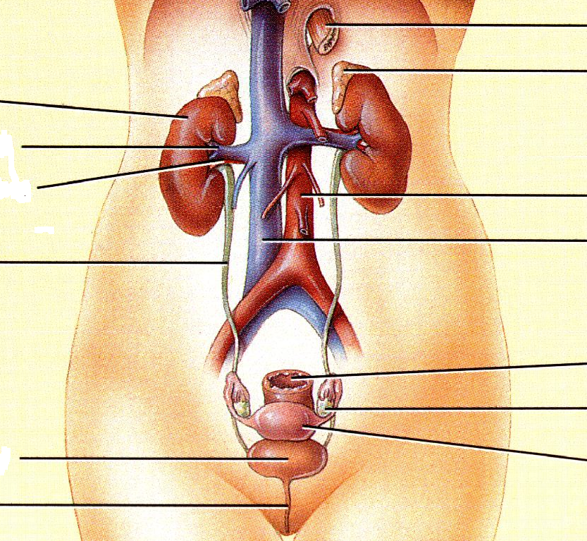

Tortora & Grabowski. (1993) Principles of Anatomy & Physiology 7th Ed. Reynolds, USA.

Label the relevant structures in the picture above

**Internal Structure of the Kidney**

There are 3 layers that surround and protect the kidney:

* the outer layer the Renal Cortex,
* the inner tissue layer Renal Medulla
* the inner most part is the funnel shaped Renal Pelvis. The Renal Pelvis is not a layer of tissue, but rather a cavity formed by the expansion of the ureter within the kidney

The renal cortex is made of renal corpuscles and convoluted tubules, whereas the inner layer renal medulla is made of loops of Henle and collecting tubules. The renal medulla also consists of wedge-shaped structure called Renal pyramids. The tip of each pyramid is its apex, which is extended to form calyces before it opens into renal pelvis. Urine flows from the renal pyramids into the calyces, then to the renal pelvis and out into the ureter.

Label the relevant structures in the picture below

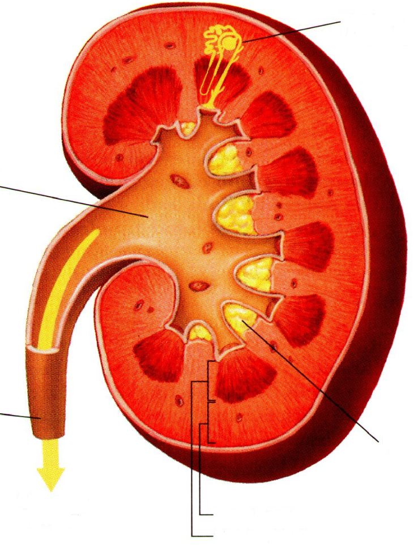

Tortora & Grabowski. (1993) Principles of Anatomy & Physiology 7th Ed. Reynolds, USA.

**Structure of the Nephron**

The nephron is the functional unit of the kidney. Each kidney contains approximately 1 million nephrons. Each nephron has two major portions: a filtering unit or otherwise called a renal corpuscle and a tubule.

Label the structure of the nephron in the diagram below

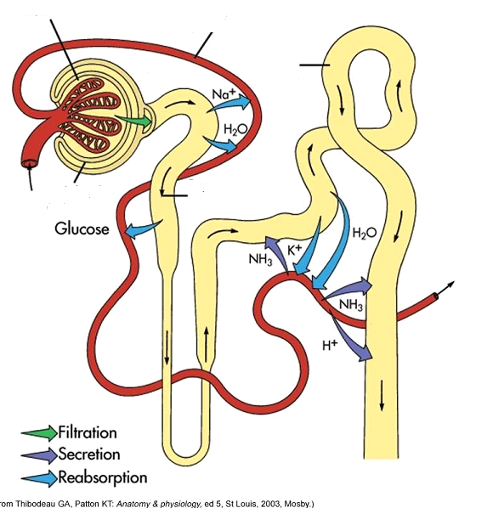

***Renal Corpuscle (Filtering unit)***

The filtering unit consists of a capillary network called glomerulus, which is enclosed by a Bowman’s capsule. The blood enters into the glomerulus by the afferent arteriole and leaves the structure via the efferent arteriole. The diameter of the efferent arteriole is smaller than that of the afferent arteriole, which helps maintain a fairly high hydrostatic pressure in the glomerulus.

Bowman’s capsule is the expanded end of a renal tubule. It is a double-walled capsule and encloses the glomerulus. The inner layer of Bowman’s capsule is permeable to water and solutes, whereas the outer layer is not permeable.

***Renal Tubule***

The renal tubule continues from Bowman’s capsule and consists of the following structures:

* Proximal convoluted tubule
* Loop of Henle
* Distal convoluted tubule

The distal convoluted tubules from several nephrons empty into collecting ducts. Several collecting ducts then unite to form a papillary duct that empties urine into a calyx of the renal pelvis. All parts of the renal tubule are surrounded by peritubular capillaries or otherwise called Vasa recta.

Briefly summarise the function of the following structures

Glomerus & Bowman’s capsule

Proximal convoluted tubule (PCT)

Loop of Henle

Distal convoluted tubules (DCT)

Collecting ducts

Vasa recta

**Functions of the Renal System**

***Kidneys***

* Regulation of blood volume (fluid balance) by conserving or eliminating water in the urine
* Regulation of acid-base balance by excreting H+ ions or conserving HCO3 \_ ions
* Excretion of nitrogenous waste products such as urea, creatinine and ammonia by forming urine
* Regulation of electrolyte balance, most importantly potassium, sodium, calcium, chloride and phosphate ions
* Regulation of blood pressure by secreting the enzyme Renin, which activates the Renin-Angiotensin mechanism to produce the potent vasoconstrictor Angiotensin II
* Maintenance of blood osmolarity by regulating the amount of water and solutes loss in the urine
* Production of hormones such as Calcitrol (Vit D precursor) and Erythropoietin
* Play a minor role in Gluconeogenesis (a process by which glucose is synthesised)

Briefly summarise the function of each of the following structures

Ureters

Urinary Bladder

Urethra

**Formation of Urine**

The formation of urine involves three major processes: glomerular filtration, tubular absorption and tubular secretion.

***GLOMERULAR FILTRATION***

Glomerular filtration is the first step in urine formation. Filtration is not selective with respect to usefulness; it is selective only with respect to size. Therefore, larger molecules such as blood cells and protein molecules are not normally filtered.

Glomerular filtration depends on three main pressures. One pressure promotes filtration and two pressures oppose filtration.

**Glomerular blood hydrostatic pressure** is the blood pressure in the glomerular capillary. It promotes filtration by forcing water and solutes in blood plasma through the filtration membrane.

**Capsular hydrostatic pressure** is the hydrostatic pressure exerted against the filtration membrane by fluid already in the capsular space and renal tubular. It opposes filtration.

**Blood colloid osmotic pressure** is due to the presence of proteins such as albumin, globulins and fibrinogen in blood plasma. This opposes filtration

What is Glomerular Filtration Rate (GFR)?

What is the average GFR and what common clinical conditions affect the GFR?

Renal auto regulation, hormonal and neural regulation also play a vital role in regulating GFR.

***Renal Auto regulation***

Renal auto regulation involves feedback mechanisms that cause either dilation or constriction in the afferent arteriole so as to counteract blood pressure changes and keep a steady GFR. For instance, if the mean arterial pressure increases too high, renal auto-regulation causes the afferent arteriole to constrict, preventing the pressure increase from being transmitted to the glomerular capillaries, and keeping the GFR from increasing. This mechanism keeps the GFR steady over a wide range of blood pressure.

***Hormonal regulation***

The hormone atrial natriuretic peptide (ANP) can influence GFR. ANP is produced in the atrial wall of the heart and whose secretion increases in response to increased plasma volume. ANP increases GFR and sodium excretion.

***Neural regulation***

Sympathetic nerves innervate the smooth muscle of the afferent arteriole. So, if the blood pressure drops too low, it results in constriction of the afferent arteriole leading to decreased GFR. Another effect of the sympathetic nervous system is to stimulate renin secretion by the juxtaglomerular cells, activating the renin-angiotensin mechanism. This mechanism help raise blood pressure.

**THE RENIN-ANGIOTENSIN MECHANISM**

Put these events in the right sequence:-

* Angiotensin II causes vasoconstriction and stimulates the adrenal cortex to produce aldosterone.
* Decreased blood pressure stimulates the Juxtaglomerular cells in the walls of the afferent arterioles to secrete renin.
* Angiotensin I is converted to Angiotensin II by Angiotensin converting enzyme in lung tissue.
* Aldosterone increases sodium reabsorption and restores the extracellular volume, which in turns increases blood pressure.

***TUBULAR REABSORPTION***

* As the filtrate passes through the renal tubules approximately 99% is reabsorbed
* Solutes are absorbed through both active and passive processes
* Water is absorbed by passive process of osmosis
* Proteins and peptides are reabsorbed by pinocytosis (active process)
* Facilitated and active transport e.g. glucose
* The majority of nutrients and HCO3 and 65% of Na and H2O are reabsorbed in the PCT
* Reabsorption continues in the loop of Henle and is responsible along with the DCT for the ability to produce and determine urine concentrate under hormonal control (juxtamedullary nephrons) (counter-current)

***Counter-Current Mechanism***

* 15 – 20% of nephrons are juxtamedullary nephrons
* These have a long loop of Henle descending leaving the proximal convoluted tubule section going into the loop and the ascending merging into the distal convoluted tubule section
* Project into the renal medulla
* Responsible for the kidneys’ ability to concentrate urine
* Able to conserve water during low water intake or excessive water loss
* This ability is due to the anatomical arrangement of the loop of Henle and its blood supply the vasa-recta

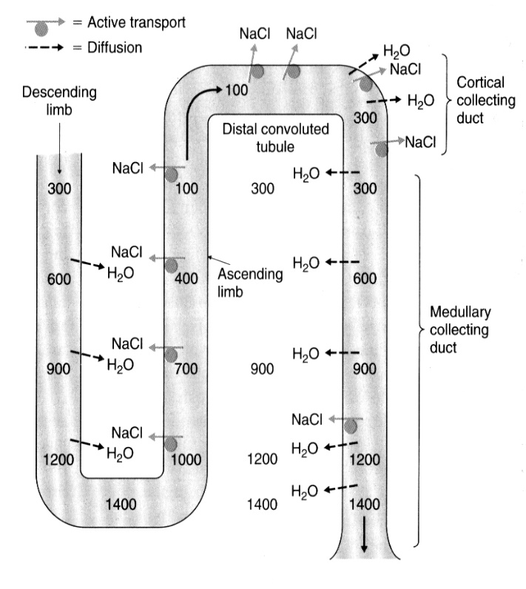

Vander AJ, Sherman J, Luciano DS(2003). Human Physiology: the Mechanisms of Body Function, 9th Ed. McGraw-Hill Education, London

* Fluid flows in opposite direction setting up a counter-current flow
* The vasa-recta runs alongside the loop
* Descending limb permeable to water but not salts
* Water moves out along concentration gradient
* Fluid in tubule becomes more concentrated
* Ascending limb impermeable to water but salts are actively reabsorbed into interstitial fluid
* Reabsorbed salts are distributed throughout the medullar interstitial fluid by the vasa-recta maintaining an osmotic gradient
* As urine passes into the collecting ducts water can diffuse out down a concentration gradient under the control of hormones
* Therefore the anatomical arrangement sets up an osmotic gradient to allow water to move out of the tubule concentrating the urine

**Control of Tubular Reabsorption**

In a 24 hour period, the kidneys form 150 to 180 litres of filtrate, but only 1 to 1.5 litres of filtrate is excreted as urine. It means when filtrate reaches the distal convoluted tubule, 99% of filtered solute and water has been reabsorbed; only about 1% of the filtrate is excreted as urine. Most reabsorption of solutes (about 65%) takes place in the proximal convoluted tubules. The distal convoluted tubule and collecting duct ‘fine-tune’ the filtrate under hormonal control. Tubular reabsorption is controlled by various hormones.

***Aldosterone***

* Secreted by adrenal cortex acts on principle cells and increases Na and water reabsorption

***Anti-diuretic Hormone (ADH)***

* Secreted by posterior pituitary in response to chemo-receptors in the hypothalamus
* Increases water permeability in principle cells

***Atrial Natriuretic Peptide (ANP) Hormone***

* Stretch receptors in atria – distension triggers release
* Decreases Na reabsorption and therefore water reabsorption

***TUBULAR SECRETION***

This mechanism also changes the composition of urine. In tubular secretion, substances are actively secreted into the filtrate in the renal tubules. Waste products such as ammonia and some of the metabolic products of medications (penicillin) may be secreted into the filtrate to be eliminated in urine. Potassium is secreted into the filtrate in response to plasma levels and aldosterone secretion. Hydrogen ions may be secreted by the tubule cells to help maintain normal pH of blood.

**Summary of Urine Production**

* Glomerulus produces 180 l/day of filtrate
* GFR regulated by auto regulation, hormonal and neural factors
* 95% of solutes and water are reabsorbed by the proximal convoluted tubule and loop of Henle
* Distal convoluted tubule reabsorbs approximately remaining 4% under influence of aldosterone and ADH
* Various waste products are secreted throughout the tubule
* 1% of filtrate is excreted (1-1.5 l/day)

**The Renal System – Review Questions**

What is the function unit of the kidney?

\_\_\_\_\_\_\_\_\_\_\_\_\_\_\_\_\_\_\_\_\_\_\_\_\_\_\_\_\_\_\_\_\_\_\_\_\_\_\_\_\_\_\_

The kidney is internally divided into three layers, the cortex, \_\_\_\_\_\_\_\_\_\_\_, and pelvis

The three processes by which urine is produced are filtration, reabsorption, and \_\_\_\_\_\_\_\_\_\_\_\_\_\_

In which region of the nephron does filtration occur? \_\_\_\_\_\_\_\_\_\_\_\_\_\_\_\_\_\_\_\_\_\_\_\_\_\_

In which region of the nephron does the majority of reabsorption occur? \_\_\_\_\_\_\_\_\_\_\_\_\_\_\_\_\_\_

In which region of the nephron does secretion occur mainly? \_\_\_\_\_\_\_\_\_\_\_\_\_\_\_\_\_\_\_\_\_

The kidneys’ main function is the production of urine. Name two other functions of the kidney:

\_\_\_\_\_\_\_\_\_\_\_\_\_\_\_\_\_\_\_\_\_\_\_\_\_\_\_\_\_\_\_\_\_\_\_\_\_\_

\_\_\_\_\_\_\_\_\_\_\_\_\_\_\_\_\_\_\_\_\_\_\_\_\_\_\_\_\_\_\_\_\_\_\_\_\_\_

What is the primary effect of ADH?

\_\_\_\_\_\_\_\_\_\_\_\_\_\_\_\_\_\_\_\_\_\_\_\_\_\_\_\_\_\_\_\_\_\_\_\_\_\_\_

Describe the two main actions of angiotensin II

\_\_\_\_\_\_\_\_\_\_\_\_\_\_\_\_\_\_\_\_\_\_\_\_\_\_\_\_\_\_\_\_\_\_\_\_\_\_\_\_\_\_\_\_\_\_\_\_\_\_

\_\_\_\_\_\_\_\_\_\_\_\_\_\_\_\_\_\_\_\_\_\_\_\_\_\_\_\_\_\_\_\_\_\_\_\_\_\_\_\_\_\_\_\_\_\_\_\_\_\_

Describe the effect of atrial natriuretic hormone:

\_\_\_\_\_\_\_\_\_\_\_\_\_\_\_\_\_\_\_\_\_\_\_\_\_\_\_\_\_\_\_\_\_\_\_\_\_\_\_\_\_\_\_\_\_\_\_\_\_\_\_\_\_\_\_\_\_\_\_\_\_\_\_\_\_

**The Renal System - References**

Alderson P, Schierhout G, Roberts I, Bunn F (2004). Colloids versus crystalloids for fluid resuscitation in critically ill patients (Cochrane Review). The Cochrane Library, Issue 2, 2004, Chichester, UK. John Wiley & Sons Ltd

Ashley C & Currie A (2004) the Renal Drug Handbook, 2nd Ed, Radcliffe Medical Press, Oxford

BMJ (2004). Clinical Evidence Concise. Vol 12, Dec 2004. BMJ Publishing Group, London

Cantarovich F, Rangoonwala B, Lorenz H, Verho M, Esnault VL, American Journal of Kidney Disease 2004 Sep; 44(3): 402-9. High-dose furosemide for established ARF: a prospective, randomized, double-blind, placebo-controlled, multi-centre trial

Corwin HL, Gettinger A, Pearl RG, Fink MP, Levy MM, Abraham E, MacIntyre NR, Shabot MM, Duh MS, Shapiro MJ (2004). Jan; 32(1): 39-52, the CRIT Study: Anaemia and blood transfusion in the critically ill – current clinical practice in the United States

Department of Health (2005), London. The National Service Framework for Renal Services. Part Two: Chronic Kidney Disease, Acute Renal Failure and End of Life Care

Department of Health (2007), London, High Impact Interventions. Saving Lives Campaign

Morton PG, Fontaine D, Hudal CM, Gallo BM. Critical Care Nursing: A Holistic Approach, 8th ed. JB Lippincott, Philadelphia

Park GR & Roe PG (2000). Fluid Balance and Volume Resuscitation for Beginners. The Alden Group, Oxford

Ralph CJ, Tanser SJ, Macnaughton PD, Sinclair CD. A Randomised Controlled Trial Investigating the Effects of Dopexamine on Gastrointestinal Function and Organ Dysfunction in the Critically Ill. Intensive Care Medicine 2002: 28: 884-890

Ronco C & Bellamo R (2003). Prevention of Acute Renal Failure in the Critically Ill. Nephron Jan 2003; 93,1

Ross & Wilson. (1992) Anatomy & Physiology in Health & Illness. 7th Ed. Churchill Livingstone, Edinburgh.

Tortora & Grabowski. (1993) Principles of Anatomy & Physiology 7th Ed. Reynolds, USA.

Walker J & Criddle LM (2003). Pathophysiology and management of abdominal compartment syndrome. American Journal of Critical Care, July 2003

**The Gastro-intestinal System**

The Gastro- Intestinal system is often a ‘forgotten’ system but is vital to the maintenance of life. The successful ingestion, utilisation and wastage of nutrients allow cells to grow and repair to allow the body to survive. This next section will look at how we use the food we ingest.

The Gastro-Intestinal system comprises of several organs, starting at the mouth and ending at the anus. Some of these organs are directly involved in the process of nutrition and some of these organs ‘assist’ with nutrition, and are known as ‘accessory muscles’.

The Gastro-Intestinal (GI) system is lined throughout with a mucous membrane, which allows for mucous to be produced to help with the smooth passage of material. However, as the GI tract moves from mouth to anus, the structure of the organ changes, so the small intestine includes villi and micro-villi, which are small folds that allow for greater surface area and absorption. The gut also is made up of muscular layers to allow for peristalsis, these are the muscularins, serosa, adventitia

**Anatomy**

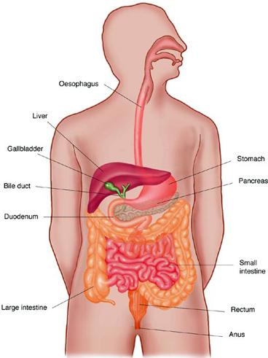Google Image 2011

We begin the process of digestion (in health) with taking food into our mouths where it is chewed into a bolus. It is then swallowed and slowly propelled down the oesophagus via peristalsis, which are muscular contractions which occur throughout the digestive system. The food bolus then enters the stomach where it is mixed with hydrochloric acid (Morton et al, 2007) The stomach does not absorb nutrients but does absorb some substances, the stomach does absorb water, water soluble drugs and alcohol only. Because the stomach will absorb water soluble drugs, it is always important to be aware how the drug you may be administering is absorbed.

Once the food mixture in the stomach is fully churned, and mixed with hydrochloric acid it is called ‘chyme’ and starts to enter the small bowel. The hydrochloric acid is secreted within the stomach.

The small bowel comprises of the duodenum, jejunum and ileum. The small bowel is where most of the absorption and utilisation of nutrients occurs. The small bowel is tubular, and lined with mucous membrane which lies in folds (called villi) which allows for a larger surface area which allows for more absorption. The food mixture is moved through the small bowel via peristalsis (Walsh et al 2007).

As the chyme enters the duodenum, digestive enzymes are released into the duodenum via the Sphincter of Oddi, from the pancreas and these digestive enzymes begin to break down the matter into usable nutrient molecules (Walsh et al 2007).

**The Stomach and Pancreas**

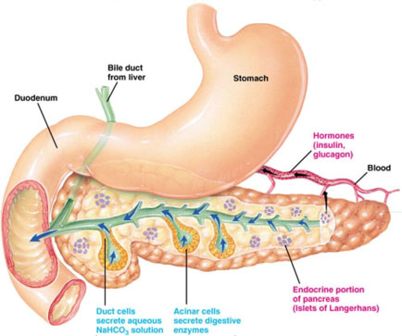

Google Image 2011

The pancreas has two main functions, endocrine and exocrine, the endocrine function is concerned with the production of insulin, and somastatin. The Exocrine function concentrates on the production of digestive enzymes such as Lipase, Amalyse and Trypsinogen.

At the same time as the introduction of digestive enzymes, bile is also released from the gall bladder and bile duct which is situated in the liver.

This mixture, once most nutrients have been absorbed is then moved to the large bowel. The large bowel stores and lubricates the waste nutrients until it is expelled from the body (Waugh et al 2014).

**The Liver**

The liver is a large organ, that is also an accessory organ to the digestive system. It receives approximately ¼ of cardiac output every minute via a complex venous system and has over 500 functions.

The liver is responsible for producing clotting factors, supporting the immune system and cleaning the blood (using Kupffer cells) as macrophages, converting nutrients and sugars into usable molecues via glycongenesis and glucongenolysis to name but a few.

The liver also ‘houses’ the gall bladder which produces bile, which will be discussed in the next section

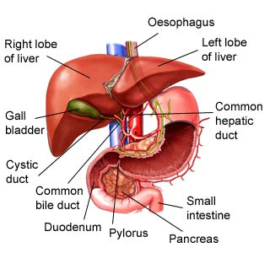

Google Image 2012

**Molecular and Chemical Process**

As discussed earlier, food is physically broken down into smaller components by chewing and peristalsis. Throughout the digestive process various chemicals are introduced to the food stuffs.

Hydrochloric acid is introduced into the stomach and this has a protective role, it will begin to destroy any bacteria that may have been ingested.

As the food leaves the stomach, bile is introduced. Bile comprises of bilirubin, salts, water and sodium bicarbonate which is a highly alkaline solution and this counters the hydrochloric acid that is mixed with the chyme from the stomach. Bile also emulsifies fats, so starts to break the food stuffs into smaller particles (Waugh et. al 2014)

Digestive Enzymes are also introduced as the food enters the duodenum, and these enzymes break down food into its component parts, so amylase is produced to break down carbohydrates, lipase to breakdown fats and trypsin to break down other food stuffs. These enzymes are very powerful, and reduce the food to molecular parts so that they can be utilised by cells (Waugh et al 2014).

Nutrients are utilised by cells via the Krebs Cycle (Morton 2007), where oxygen and nutrients are ‘carried’ into the cell for utilisation by the hormone insulin. A very simple diagram is below:

**Krebs Cycle**

Nutrient

O2 ↘

↘

CO2

The rate of how quickly this process occurs is determined by several factors, but the chemical process is known as metabolism.

In acute illness, this process is speeded up as the body has to repair cells at a faster rate than in ‘health’ and this is known as catabolism.

**Utilisation of Nutrients and Blood Supply**

Having discussed the anatomy of the digestive system and how it works, and then how food stuffs are broken down we will now look at how the nutrient molecules move from the Gastro-Intestinal system to all body parts.

The Gastro-Intestinal system is a collection of very vascular organs and is served by the mesenteric and splenic arterial and venous systems. These vessels absorb nutrients and water from the gut and will transfer the nutrients to organs, but also to the liver, to be converted into a usable form of energy (Walsh et al 2007). The liver also metabolises waste and it is then transported via the blood supply, back to the gut where it is stored until it is expelled. This blood supply is very fragile in acute or critical illness.

**The Gastro-intestinal System – Review Questions**

What is the function of the Gastro-Intestinal system?

\_\_\_\_\_\_\_\_\_\_\_\_\_\_\_\_\_\_\_\_\_\_\_\_\_\_\_\_\_\_\_\_\_\_\_\_\_\_\_\_\_\_

What is the GI system lined with? \_\_\_\_\_\_\_\_\_\_\_\_\_\_\_\_\_\_\_\_\_\_\_\_\_\_\_

What does the stomach absorb? \_\_\_\_\_\_\_\_\_\_\_\_\_\_\_\_\_\_\_\_\_\_\_\_\_\_\_

What surrounds the structure of the small and large intestine? \_\_\_\_\_\_\_\_\_\_\_\_\_\_\_\_\_\_\_\_\_\_\_\_\_

What is the function of the small intestine?

\_\_\_\_\_\_\_\_\_\_\_\_\_\_\_\_\_\_\_\_\_\_\_\_\_\_\_\_\_\_\_\_\_\_\_\_\_\_\_\_\_\_\_

What is the function of the large intestine?

\_\_\_\_\_\_\_\_\_\_\_\_\_\_\_\_\_\_\_\_\_\_\_\_\_\_\_\_\_\_\_\_\_\_\_\_\_\_\_\_\_\_\_\_

What are the two functions of the pancreas?

\_\_\_\_\_\_\_\_\_\_\_\_\_\_\_\_\_\_\_\_\_\_\_\_\_\_\_\_\_\_\_\_\_\_\_\_\_\_

\_\_\_\_\_\_\_\_\_\_\_\_\_\_\_\_\_\_\_\_\_\_\_\_\_\_\_\_\_\_\_\_\_\_\_\_\_\_

What does insulin do?

\_\_\_\_\_\_\_\_\_\_\_\_\_\_\_\_\_\_\_\_\_\_\_\_\_\_\_\_\_\_\_\_\_\_\_\_\_\_\_

Name 5 main functions of the liver:

i)

ii)

iii)

iv)

v)

What is glycogen?

\_\_\_\_\_\_\_\_\_\_\_\_\_\_\_\_\_\_\_\_\_\_\_\_\_\_\_\_\_\_\_\_\_\_\_\_\_\_\_\_

**The Gastro-intestinal System - References**

[www.dansmedschoolnotes.wikidot.com/gi](http://www.dansmedschoolnotes.wikidot.com/gi) (accessed 16.09.2014)

[www.vacularweb.org/vascularhealth//mesenteric-ischaemic](http://www.vacularweb.org/vascularhealth//mesenteric-ischaemic) (cited 16.09.14)

Morton et al (2007) ‘Critical Care Nursing: A Holistic Approach’, Lippincott Williams

Walsh et al (2007) ‘Clinical Nursing and Related Sciences, 7th Ed, balliere tindall

Waugh et al (2014) ‘Anatomy and Physiology in Health and Illness’ 12th Ed. Churchill Livingstone

**Neurological**

**The Brain & Nervous System**

**Introduction**

This material will cover the anatomy and physiology of the brain and nervous system in detail. This is vital to ensure the understanding of how the brain and nervous system are affected by injury and disease and thereby recognising the care and treatment needs of persons with damage to this system.

**The Nervous System**

The nervous system is comprised of anatomic divisions, the Central Nervous System (CNS), consisting of the Brain and the Spinal Cord contained within the skull and vertebral column; and the Peripheral Nervous System (PNS), consisting of the cranial and spinal nerves, their peripheral combinations and the peripheral portions of the autonomic nervous system.

**The Brain**

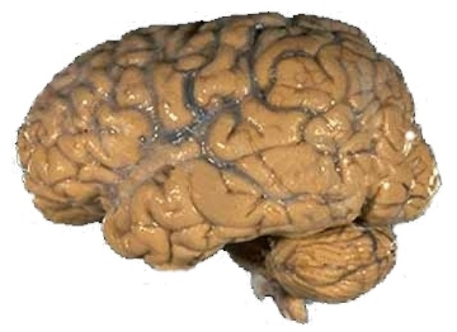

The brain is the most complex structure in the known Universe. It comprises many highly specialized component parts each of which is associated with specific tasks, for example memory and vision.

The functioning of the human brain not only allows us to sense our environment and coordinate movements but also gives rise to attributes such as consciousness.

Consciousness is difficult to define and includes such attributes as a sense of past and future, an inner voice and self-awareness. Hickey, (2013) defines consciousness as “a general awareness of oneself and the surrounding environment; it is a dynamic state and can, therefore, change.” Altered level of consciousness is the earliest and most sensitive indicator of global brain damage.

Intelligence is commonly interpreted as the external sign of a conscious being. It is the result of millions of years of evolution. The distant origins of the human brain can be seen in simple reptiles and mammals.

The adult human brain weighs an average of 1.4 kg, or about 2 % of the total body weight. It contains approximately 100 billion neurons. These neurons make up the most complex and highly organized network.

The human brain is responsible for managing the daily operations of the human body and for interpreting the vast amount of information it receives.

It is responsible for many of the qualities that make each individual unique, i.e. thoughts, feelings, emotions, talents, memories, and the ability to process information. The brain is responsible for maintaining homeostasis by controlling and integrating the various systems of the body.

**Anatomy and Physiology**

**Central Nervous System**

Bony and membranous coverings protect the brain and spinal cord. It is cushioned by cerebrospinal fluid. The skull is a rigid compartment of fused bones that covers the brain. In its base is a large opening known as the Foramen Magnum, which is where the cranial cavity and the vertebral canal meet. There are many other smaller openings in the skull that provide channels for cranial nerves and blood vessels. Three layers of membranes known as meninges also protect the brain and spinal cord. These are:

1. Dura Mater – A tough outer covering lining the skull, extending through the foramen magnum and lines the vertebral column (although does not attach to the vertebral column itself). It is separated from the arachnoid mater by the subdural space through which many fine blood vessels pass.
2. Arachnoid Mater – A delicate impermeable membrane that is separated from the third layer by the subarachnoid space.
3. Pia Mater – this is the innermost layer of membrane that adheres to the brain and the spinal cord.

The subarachnoid space contains cerebrospinal fluid (CSF). Large subarachnoid spaces at the base of the brain are known as cisternae (cisterns).

CSF circulates upwards and over the surface of the brain and downwards around the spinal cord providing a “cushioning” effect against trauma for these structures. The fold of the meninges provide support for the spinal cord and the brain. The dura folds vertically along the mid-saggital line within the skull to form the ‘falx cerbri’.

This is the fold that separates the two cerebral hemispheres. At the superior and inferior boundaries the layers of the falx cerbri separate and form the superior and inferior longitudinal sinuses that function as cerebral veins.

At the posterior end of the falx cerebri the dura projects laterally and forms the tentorium cerebelli (this is an important landmark in brain used to describe sites of lesions e.g. supratentorial, etc). The tentorium cerebelli supports the temporal and occipital lobes and separates posterior cranial fossa from the rest of the cranial cavity. The pia mater is closely attached to the surface of all of the folds/ “bumps” of the brain, (the gyri). The furrows/fissures of the brain are known as sulci.

The central nervous system can be divided into six major regions:

1. Telencephalon (cerebrum)
2. Diencephalon (thalamus and hypothalamus)
3. Mesencephalon (midbrain)
4. Metencephalon (divided into the pons and cerebellum)
5. Myelencephalon (medulla)
6. Spinal Medulla (spinal cord)

You will often hear the areas of the brain referred to as, Forebrain = Telencepahlon and Diencephalon, Mid Brain = Mesencephalon and Hind Brain = Myelencephalon and Metencephalon

1. **Cerebrum (Telencephalon)**

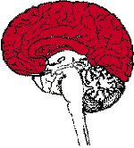The cerebrum is the control centre of the brain and is the largest and most prominent part of the brain being 85% of the weight and occupying most of the space in the skull. It is responsible for all of the voluntary (conscious) activities of the body. It is also the site of intelligence, learning and judgement, language, conscious thought, vision and other senses and personality development. The Cranial Nerve -Olfactory Nerve (I) originates here.

The cerebrum is divided into two cerebral hemispheres (Left and Right) by a deep groove however they are joined at the base by the corpus callosum together with a bundle of neurons known as a tract. This tract tells each half of the brain what the other half is doing. The cerebrum has prominent folds and grooves that increase the surface area. It is important to note that the *left* hemisphere of the cerebrum controls the *right* side of the body and the *right* side controls the *left* side. The left side to the right side and vice versa sends sensations and commands to muscles. The *righ*t hemisphere is associated with creativity and artistic ability whereas the *left h*emisphere is associated with analytical and mathematical ability.

The cerebrum contains thick layers of unmyelinated neurons that have a grey appearance hence the term grey matter. Each hemisphere of the cerebrum is divided into four regions known as lobes. These lobes are named after the skull bones that cover them. The cerebrum has two surfaces – A folded outer surface called the cerebral cortex (unmyelinated neurons/axons - grey matter) and the inner surface called the cerebral medulla made up of myelinated neurons/axons – white matter.

In summary, the cerebrum determines intelligence, and personality, motor function, planning and organisation, interpretation of sensory impulses, sense of smell and touch sensation.

Let’s Revise!

Take some time now and revise the anatomy and physiology of the brain in more detail and then complete the questions below:

Name the four lobes of the brain and their main functions

1. Name:

Function:

1. Name:

Function:

1. Name:

Function:

1. Name:

Function:

1. **Diencephalon**

[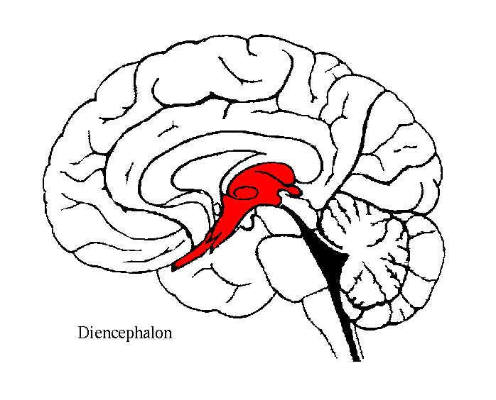](http://aolsearch.aol.co.uk/redir?urn=http://www.ims.uni-stuttgart.de/phonetik/joerg/sgtutorial/graphic/diencephalon.gif&url=http://www.ims.uni-stuttgart.de/phonetik/joerg/sgtutorial/graphic/diencephalon.gif&&requestId=9ce2087f8cbe64a4&clickedItemRank=3&source=googleImage&searchType=IS&partner=Google&query=diencephalon)This is the area of the brain that includes the thalamus, hypothalamus, epithalamus and subthalamus. It is located above the mesencephalon of the brain stem and surrounds the third ventricle. Optic Nerve (II) and the Optic Chiasm are in this area.

2.1 The **thalamus** is a large, two-lobed grey matter structure located at the top of the brain stem. It contains several relay nuclei, most of which lead directly to the cortex. It is adjacent to the third and on the floor of the fourth ventricle. It has both sensory and motor functions. Almost all sensory information enters this structure where neurons send information to the overlying cortex. Axons from every sensory system (except olfaction) synapse here, as the last relay site before the information reaches the cerebral cortex. It may play a role in learning and memory. It influences mood, fear, rage, love and hate. It also contains many nuclei that are concerned with specific senses such as touch and temperature.

* 1. The **Hypothalamus** is comprised of 22 nuclei. The pituitary gland has an influence on the endocrine and the autonomic nervous system; this helps regulate homeostasis and hormones. It is attributed as co-ordinating behaviours such as sleeping, sex, feeding, temperature control/regulation, emotions, and fluid balance and muscle control.
  2. Within the **Epithalamus** the pineal gland may influence sleep-wake cycle. Its other function is the connection between the [limbic system](http://en.wikipedia.org/wiki/Limbic_system) to other parts of the brain, and the regulation of [hunger](http://en.wikipedia.org/wiki/Hunger) and [thirst](http://en.wikipedia.org/wiki/Thirst) by the habenula

2.4 The **Subthalamus** is involved in controlling motor functions.

In summary the diencephalons is responsible for chewing, equilibrium, eye movement, vision, facial sensation, hearing phonation, respiration, salivation, swallowing, smell, taste and directing sense impulses throughout the body.

1. **Mesencephalon (midbrain)**

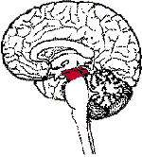This is positioned between the [hindbrain](http://www.brainexplorer.org/glossary/hindbrain.shtml) and the [forebrain](http://www.brainexplorer.org/glossary/forebrain.shtml), where it forms part of the [brainstem](http://www.brainexplorer.org/glossary/brainstem.shtml) connecting it to the forebrain. The midbrain is responsible for controlling sensory processes. It is also the rostral part of the brainstem that, if impaired in its core (i.e. the **tegmentum**), will result in the loss of consciousness or coma, because the rostral manages the end of the reticular formation. The occulomotor Nerve (III) and the Trochlear Nerve (IV) originate here.

The dorsal or posterior part has the **superior colliculus**, which is important for visual system reflexes, and the **inferior colliculus**, which is important for auditory system function.

The ventral or anterior part has the **cerebral peduncle**, which is a huge bundle of axons travelling from the cerebral cortex into/ through the brainstem; those fibres are important for voluntary motor function. Two other structures in the depth of the midbrain that are important for normal motor function are the **red nucleus** (not visible) and the **substantia nigra**. The [trochlear nerve](http://en.wikipedia.org/wiki/Trochlear_nerve) comes out of the posterior surface of the midbrain, below the inferior colliculus. In summary then this area controls responses to sight, eye movement, pupil dilation, body movement, and hearing.

1. **Metencephalon (divided into the pons and cerebellum)**

The metencephalon is a [developmental](http://en.wikipedia.org/wiki/Morphogenesis) categorization of portions of the [central nervous system](http://en.wikipedia.org/wiki/Central_nervous_system). The metencephalon is composed of the [pons](http://en.wikipedia.org/wiki/Pons) and the [cerebellum](http://en.wikipedia.org/wiki/Cerebellum); contains a portion of the fourth ventricle; and the [trigeminal nerve](http://en.wikipedia.org/wiki/Trigeminal_nerve) V, [abducens nerve](http://en.wikipedia.org/wiki/Abducens_nerve) VI, [facial nerve](http://en.wikipedia.org/wiki/Facial_nerve) VII, and a portion of the [vestibulocochlear nerve](http://en.wikipedia.org/wiki/Vestibulocochlear_nerve) VIII.

**4.1 Pons**

The **pons** (sometimes **pons Varolii** after [Costanzo Varolio](http://en.wikipedia.org/w/index.php?title=Costanzo_Varolio&action=edit)) is a protuberance on the [brain stem](http://en.wikipedia.org/wiki/Brain_stem). It is part of the [autonomic nervous system](http://en.wikipedia.org/wiki/Autonomic_nervous_system) and the Pontine Nuclei, located in the anterior portion of the pons, relay information from the cerebrum to the cerebellum. It is just superior to the medulla oblongata is the pons, which contains ascending and descending nerve tracts and several nuclei. Other important pontine areas include the Pontine Sleep and the respiratory centre.

The Nuclei for Cranial Nerves trigeminal V, abducens VI, facial VII, vestbulocochlear VIII are contained within the posterior pons.

**4.2 Cerebellum**

The cerebellum is the second largest part of the brain. It is a small cauliflower shaped structure located at the back of the skull. It coordinates and balances muscle movements so that the body can move gracefully and efficiently.

The cerebellum controls balance, posture and coordination. It receives sensory impulses from muscles, tendons, joints, eyes and ears together with input from other parts of the brain. Processing information about position it controls posture by keeping skeletal muscles in a constant state of partial contraction. The cerebellum coordinates rapid and ongoing movements.

The cerebellum appears to be related to the learning of how to perform physical activities through training the cerebellum to coordinate the correct muscles. The cerebellum function is involuntary therefore learning a completely new physical activity can be very difficult.

1. **Myelencephalon (medulla)**

This is approximately the inferior 3cm of the brain stem and it is continuous through the foramen magnum of the skull with the spinal cord.

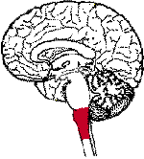In the anterior portion of the pons are the corticospinal fibres that mostly cross over in the medulla and continue down the cord as the corticospinal tracts these are involved in voluntary movement.

Several obvious nuclei are present in the posterior part of the medulla. These are the areas for synapses of any ascending pathways carrying sensory information. The nuclei of the cranial nerves are the IX glossopharyngeal, X vagus, XI accessory and XII hypoglossal.

Some parts of the cranial nerve nuclei form the “Vital Centres” of the Medulla. These centres include the following:

**Cardiac Centre** Cardio-acceleratory and cardio-inhibitory centres are basically reflex centres, receiving impulses that arise in receptors in several body areas and sending impulses to the heart to regulate its rate of beat according to the need for oxygen and activity levels.

**Respiratory Centre** Inspiratory, expiratory, apneustic and vagal nuclei form part of the system responsible for intake of air into the lungs and further expiratory activity.

**VasoMotor Centre** Vasodilator and Vasoconstrictor centres are concerned with the diameter of muscular blood vessels and thereby help to control the blood pressure.

Another important part of the medulla is a group of cells known as **THE RETICULAR ACTIVATING SYSTEM or RETICULAR FORMATION (RAS).** The Reticular Activation System (RAS) actually helps to alert, or awaken, the upper parts of the brain, including the cerebral cortex.

1. **Spinal Medulla (spinal cord)**

The spinal cord acts as a communication link between the brain and the peripheral nervous system (PNS). It is continuous with the brain and emerges from an opening at the base of the skull. The spinal cord stretches downward for approximately 42 - 45 cm through the vertebral column.

There are 31 pairs of spinal nerves, (these are part of the PNS), that emerge from the spinal cord and branch out to both sides of the body. The nerves are named according to their respective vertebrae. Nerves are axons that are bundled together. Each spinal nerve consists of a **Dorsal Root** and a **Ventral Root.** These dorsal roots contain neurons that carry signals to the CNS from various types of receptors. The **Ventral Roots** contain the axons of motor neurons that contact and carry information to the muscles and glands effectors. Within the spinal cord and elsewhere in the body there are Interneurons – these are neurons that connect neurons to each other. In addition to carrying impulses to and from the brain, the spinal cord regulates reflexes. A reflex is the simplest response to a stimulus. Sneezing and blinking are two examples of reflexes. A reflex produces a rapid motor response. Reflexes are very fast, and most reflexes never reach the brain.

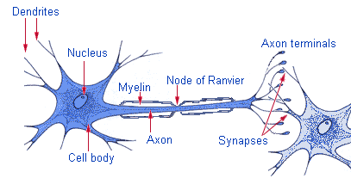

**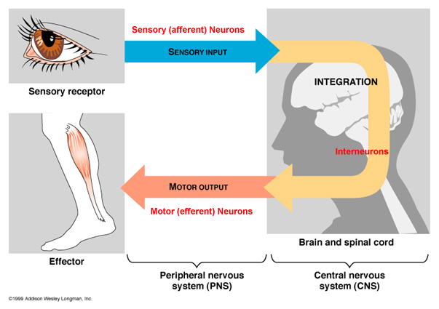**

Below are the three areas of the brain and their function/s

|  |  |  |
| --- | --- | --- |
|  | **NAME** | **FUNCTION/S** |
| 1. | Medulla Oblongata | * Pathway for motor & sensory impulses * Consciousness & arousal * 3 reflex centres * Cranial nerves viii, ix, x, xi, xii originate here |
| 2. | Pons | * Relays impulses from one side to the other * Cranial nerves v, vi, vii, viii. |
| 3. | MidBrain | * Relays motor impulses from cerebral cortex to the pons & sensory impulses from the spinal to the Thalamus * Cranial nerves iii, iv originate here |

**Cerebro Spinal Fluid**

What are the functions of cerebrospinal fluid?

Functions:

Formation:

**This Diagram illustrates the formation of Cerebral spinal fluid**

****

Lindsay & Bone (2010)

Lindsay & Bone (2010)

How many layers are there?

Describe their structures:

##### Identify how many layers of meninges there are and describe their structures

**Cerebellum**

Is responsible for involuntary coordination of voluntary motor movement

- Balance

- Equilibrium

- Muscle tone

**Reticular Formation**

Reticular Formation is a core of neural tissue in the brain stem

•  Alerts the cerebral cortex to incoming sensory signals:

* Arousal
* Attention
* Cardiac Reflexes
* Motor Functions
* Regulates Awareness
* Relays Nerve Signals to the [Cerebral Cortex](http://biology.about.com/library/organs/brain/blcortex.htm)
* Sleep

**Spinal Cord**

The spinal cord has two major functions:

* Transmit impulses to and from the brain
* House spinal reflexes.

Tracts that carry sensory information to the brain are called ascending tracts; whilst tracts that carry motor information from the brain are called descending tracts

The names that identify nerve tracts identify the origin and termination of the fibres within the tract.

How many pairs of spinal nerves do we have? \_\_\_\_\_\_\_\_\_ pairs

Name the 12 cranial nerves and their functions

**I Name: Function:**

**II Name: Function:**

**III Name: Function:**

**IV Name: Function:**

**V Name: Function:**

**VI Name: Function:**

**VII Name: Function:**

**VIII Name: Function:**

**IX Name: Function:**

**X Name: Function:**

**XI Name: Function:**

**XII Name: Function:**

To help remember the order of the cranial nerves try to learn the mnemonic: **O**n **O**ld **O**lympus **T**owering **T**op **A** **F**amous **V**ocal **G**erman **V**iewed **S**ome **H**ops.

To help remember the type of cranial nerve (motor or sensory) try to learn this mnemonic:

**Some Say Marry Money, But My Brother Says Big Breasts Matter More**

Sensory, sensory motor, motor, both, motor, both, sensory, both, both, motor, motor in the order of cranial nerves starting from the olfactory (cranial nerve I).

**Peripheral Nervous System (PNS).**

Like the CNS, the PNS is split into two components

Sensory-somatic system that consists of the cranial nerves and spinal nerves

Autonomic system that is further split into the parasympathetic and sympathetic system

**Let’s look at these in more detail.**

**Sensory-somatic System**

The **somatosensory system** includes several types of sensation from the body, such as light touch, pain, pressure, temperature, and joint and muscle position sense (also called proprioception).

There are three different pathways in the spinal cord that help in these processes and each have different targets in the brain. Any sensory system going to the cerebral cortex will have to cross over at some point, because the cerebral cortex operates on a contralateral opposite side-to-side basis.

The first is called **discriminative touch**, which includes touch, pressure, and vibration perception, an example is the brains ability to analyse the raised letters with our fingertips, or describe the shape and texture of an object without seeing it. The discriminative touch system crosses high in the medulla.

The second is **pain and temperature**, which is just what it sounds like, and also includes the sensations of itch and tickle. The pain system crosses low - in the spinal cord.

The third is **proprioception**, and includes receptors for what happens below the body surface: muscle stretch, joint position, tendon tension, etc. This primarily targets the **cerebellum**, which needs continuous feedback on what the muscles are doing. The proprioceptive system is going to the cerebellum, which works ipsilaterally, the same side. Therefore this system doesn't cross.

**Autonomic Nervous System**

The autonomic nervous system ANS consists of sensory and motor neurons that run between the central nervous system (especially the hypothalamus and medulla oblongata) and various internal organs such as the heart, lungs and liver. The ANS is a regulatory structure that helps the body adapt to changes in their internal/external environment. It adjusts or modifies some functions in response to stress, i.e. “Fight or Flight”. The ANS helps to regulate: -

* blood vessels' size and diameter affecting blood pressure
* the heart's rate, electrical activity and ability to contract
* the diameter of the bronchus

The ANS also regulates the movement and work of the stomach, intestine and salivary glands, the secretion of insulin and the urinary and sexual functions. The ANS acts through a balance of its two components, the sympathetic nervous system and parasympathetic nervous system.

List the effects the parasympathetic and sympathetic systems have on the following: -

**Lungs**

**Parasympathetic Sympathetic**

**Heart**

**Parasympathetic Sympathetic**

**Pupils**

**Parasympathetic Sympathetic**

**Gut**

**Parasympathetic Sympathetic**

**Liver**

**Parasympathetic Sympathetic**

**Cerebral Circulation**

Although the brain is approximately 2% of the body’s total weight, it utilises 20% of the cardiac output. Blood is supplied via the two internal carotid arteries and the two vertebral arteries. These join at the base of the brain forming the Circle of Willis. It also utilises 20% of all oxygen content in the body. The carotid arteries and their branches supply the anterior portion of the brain whereas the vertebrobasilar system supplies the posterior portion of the brain.

The brain receives its blood supply from the heart by way of the aortic arch that gives rise to the brachiocephalic otherwise known as the innominate artery, left common carotid artery and the left subclavian artery.

Venous blood flows peripherally via superficial cerebral veins and centrally via the deep cerebral veins into the venous sinuses. These lie between the outer endosteal and the inner meningeal layer of the dura, which in turn drain into the internal jugular veins. The cerebral veins are thin walled and have no valves. There are numerous venous connections between cerebral veins, dural sinuses, venous systems of the meninges, skull, scalp and nasal sinuses. This can facilitate the propagation of thrombus or spread of infection between these vessels (Harrigan & Deveikis 2009).

Cerebral blood flow (CBF) is about 50-ml/100 g of brain/minute (approx 750 mls/min). Studies have shown that CBF and cerebral metabolism is higher in the grey matter than the white matter. This means that the oxygen extraction fraction (OEF) remains about the same (approximately 40%) throughout the brain, therefore, in normal resting human brain CBF is a reliable reflection of cerebral metabolism (Dinsmore 2013).

CBF depends on cerebral perfusion pressure (CPP) and cerebrovascular resistance. The perfusion pressure is the difference between systemic arterial pressure and venous pressure at the exit of the subarachnoid space, the latter being estimated by the intracranial pressure.

**Cerebral Blood Flow**

Cerebral blood flow is calculated by subtracting the ICP from the mean arterial pressure (MAP) and dividing by the cerebrovascular resistance (CVR), or by dividing cerebral perfusion pressure (CPP) by CVR.

MAP – ICP

CBF = CVR **or** CPP

CVR

Average CBF 50 ml/100 Gm/min

Ischemia CBF < 18 – 20 ml/100 Gm/min

Tissue death < 8 – 10 ml/100 Gm/min

Hyperemia (CBF in excess of tissue demand) > 55 – 60 ml/100 Gm/min

Below describes the **Blood Brain Barrier (BBB)**, and explains how it works and why it is important

How it works:

The BBB is semi-permeable; that is, it allows some materials to cross, but prevents others from crossing. In most parts of the body, capillaries, are lined with endothelial cells. Endothelial tissue has small spaces between each individual cell so substances can move readily inside and the outside of the vessel. However, in the brain, the endothelial cells fit tightly together and substances cannot pass out of the bloodstream. (Some molecules, such as glucose, are transported out of the blood by special methods.) Glial cells (astrocytes) form a layer around brain blood vessels and may be important in the development of the BBB. Astrocytes may also be responsible for transporting ions from the brain to the blood.

**Functions of the BBB –**

## Protects the brain from "foreign substances" in the blood that may injure the brain.

1. Protects the brain from hormones and neurotransmitters in the rest of the body.
2. Maintains a constant environment for the brain.

## General Properties of the BBB

1. Large molecules do not pass through the BBB easily.
2. Low lipid (fat) soluble molecules do not penetrate into the brain. However, lipid soluble molecules, such as barbituate drugs, rapidly cross through into the brain.
3. Molecules that have a high electrical charge to them are slowed.

## The BBB can be broken down by:

1. Hypertension (high blood pressure): high blood pressure opens the BBB
2. Development: the BBB is not fully formed at birth.
3. Hyperosmolitity: a high concentration of a substance in the blood can open the BBB.
4. Microwaves: exposure to microwaves can open the BBB.
5. Radiation: exposure to radiation can open the BBB.
6. Infection: exposure to infectious agents can open the BBB.
7. Trauma, Ischemia, Inflammation, Pressure: injury to the brain can open the BBB

**Neurological - References**

Dinsmore J; (2013) Traumatic brain injury: an evidence-based review of management; Continuing Education in Anaesthesia, Critical Care & Pain.(2013) 13 (6):189-195 first publisehed online February 24,2013.

Harrigan MR, Deveikis JP. Handbook of Cerebrovascular Disease and Neurointerventional Technique. Heidelberg: Humana Press; 2009.

Hickey J. V (2013). The Clinical Practice of Neurological and Neurosurgical Nursing. Seventh Edition. Lippincott Williams & Wilkins .USA

Grand W, Hopkins LN. Variations in Clinical Anatomy. In: Vasculature of the Brain and Cranial Base. New York: Thieme; 1999

Lindsay K.W & Bone I; G Fuller (2010) Neurology and Neurosurgery Illustrated.

Fifth Edition. Churchill livingstone, UK

**Pain Management**

**Definition of Pain**

Pain is a very personal experience; it differs from one individual to another. One of the most commonly used expressions we hear is “pain is what the patient says it is and occurs whenever the patient says it does” (McCaffery, 1972).

**What is the function of Pain?**

Pain motivates the individual to protect oneself whilst the body is healing or to remove oneself from any further damage/danger. It acts as a defence mechanism against tissue damage. The process of nociception describes the normal processing of pain and the responses to noxious stimuli that are damaging or potentially damaging to normal tissue. Although the experience of pain is distressing it is essential for survival. It is a major symptom in many medical conditions, and can significantly interfere with a person's quality of life and general functioning. Lesions of nervous pathways lead to motor damage - paraplegia and sensory damage.

**Classification of pain**

Acute up to 3 months

Chronic non-malignant e.g. lower back pain, Arthritis

Cancer pain in multiple sites and from several pathophysiologies of the symptom complex

Neuropathic pain nerve damage or disease

Nociceptive pain damage to tissue

**Nociception**

There are four basic processes involved in nociception (McCaffery and Pasero, 1999). These are:

* transduction
* transmission
* perception
* modulation

**Transduction**

Transduction occurs when free nerve ending (nociceptors) of C fibres and A- delta fibres of primary afferent neurones respond to noxious stimuli. Nociceptors are distributed in the somatic structures such as skin muscles connective tissue, bones and joints and visceral structures such as the liver, gastro-intestinal tract.

A-delta are large diameter fast conducting myelinated fibres that respond to mechanical stimuli over a certain intensity. The quality of pain transmitted is sharp, stinging, pricking, localized fast pain sensation. C fibres are much smaller in diameter, slow conducting, unmyelinated with a polymodal response to a variety of noxious stimuli. The quality of pain is dull, diffuse, aching, burning and often referred to as slow pain.

Noxious stimuli can be:-

Mechanical – pressure, swelling, abscess, incision, tumor growth

Thermal – burn, scald

Chemical – excitatory neurotransmitter, toxic substance, ischemia, infection.

The cause of stimulation may be internal e.g. pressure from a growth or external e.g. a burn this then causes a release of chemical mediators from the damaged cells including:

Prostaglandin serotonin substance P bradykinin

Potassium histamine

These chemical mediators activate/sensitise the nociceptors to the noxious stimuli. For a pain impulse to be generated an exchange of potassium and sodium irons (polarization and re- polarisation) occurs at the cell membrane resulting in an action potential and generation of a pain impulse.

**Transmission of Pain**

Pain is transmitted via three different processes

* from the site of transduction along the nociceptor fibres to the dorsal horn in the spinal cord
* from the spinal cord to the brain stem
* through connections between the thalamus, cortex and higher levels of the brain

**C fibres** and **A delta fibres** terminate in the dorsal horn of the spinal cord. At the terminal ends of these fibres is the synaptic cleft. Pain impulses are transmitted between this cleft and the Nociceptive dorsal horn neurones via neurotransmitters (listed below).

Adenosine triphosphate

Glutamine

Calcitonin gene-related peptide

Bradykinin

Nitric oxide

Substance P

The pain impulse is then transmitted from the spinal cord to the brain stem and thalamus via the spinothalmic and spinoparabrachial pathway. There is no dedicated pain centre in the brain, therefore the impulses are further directed to multiple areas and then further processed.

**Perception of Pain**

Perception of pain is multidimensional consisting of affective-motivational, sensory-discriminative, emotional and behavioural components. Once this transmission reaches the brain stem and thalamus multiple cortical areas are activated resulting in a response.

The reticular system. – responsible for autonomic and motor responses

Somotosensory cortex – responsible for the perception and interpretations of sensations. It identifies the intensity, type and locations of the pain. It evokes memory of past experiences and cognitive activities.

Limbic system - the emotional and behavioural responses to pain e.g. mood, attention, motivation – also past experiences.

**Modulation**

This involves changing, increasing (excitatory) or decreasing (inhibiting) the pain transmission in the spinal cord. This complex modulation process is undertaken by the descending modulatory pain pathways. The inhibitory neurotransmitters block or partially block the transmission the pain impulse. Inhibitory neurotransmitters include

* Endogenous opioids (enkephalins and endorphins)
* Serotonin
* Norepinephirine
* Gamma-aminobutyric acid
* Neurotensin
* Acetylcholine
* Oxytocin

This pain modulation will depend on the individual’s ability to produce different amounts of inhibitory neurotransmitters (found throughout the central nervous system) which helps to explain the wide variation of pain perception in people.

**The Gate theory**

The most popular theory concerning pain transmission is known as the “Gate Control Theory” (Melzack & Wall, 1965 & 1982). It is thought to be the most widely accepted explanation of pain phenomena currently available. There have been some minor changes to this theory but the basis remains the same.

**Pain Assessment**

Before we can treat pain effectively, we must accurately assess the pain the patient is experiencing. To do this we need to have a basic understanding of the autonomic nervous system.

**Autonomic Nervous System**

This governs the actions of the muscles, organs and glands. Vital functions such as heartbeat, salivation and digestion continue without conscious direction whether we are awake or asleep. The autonomic nervous system is divided into two parts, the sympathetic and the parasympathetic, the effects of one generally balances the effects of the other to maintain homeostasis.

When the body is in homeostasis, the main function of the sympathetic division is to counteract the parasympathetic affects just enough to carry out normal processes requiring energy. During extreme stress, however, the sympathetic dominates the parasympathetic. When people are confronted with a stress condition, for example, due to pain, their bodies become alert and they sometimes perform feats of unusual strength. Fear also stimulates the sympathetic division, as do a variety of other emotions and physical activities.

Activation of the sympathetic division of the **Autonomic Nervous System** sets into operation a series of physiological responses collectively called the flight or fight response.

It produces the following effects:

1. Pupils of the eye dilate
2. The heart rate and force of contraction increase and the blood pressure increases
3. The blood vessels of the skin and viscera constrict
4. The remainder of the blood vessels dilate.This causes a faster flow of blood into the dilated blood vessels of Skeletal muscles, cardiac muscle and lungs – fight or flight response.
5. Rapid and deeper breathing occurs and the bronchioles dilate to allow faster movement of air in and out of the lungs.
6. Blood sugar level rises as liver glycogen is converted to glucose to supply the body’s additional energy needs
7. The medullae of the adrenal glands are stimulated to produce Epinephrine and Norepinephrine
8. Processes that are not essential for meeting the stress situation are inhibited. For example, muscular movements of the gastrointestinal tract and digestive secretions are slowed down or even stopped

**Pain Management – Review Questions**

2. How can Acute Pain Affect the Blood Sugar? Why does this occur?

1. How and why will the biochemistry change for patients experiencing Acute Pain?

Sodium

Potassium

Urea & Creatinine

Liver Function Bloods

Ph

3. In your own words describe the principles of the gate control theory:

5. Make a list of the adverse signs and symptoms of pain and provide a brief explanation of why these would occur.

Respiratory

Cardiovascular

Gastrointestinal

Renal

Endocrine and metabolic

4. What is congenital insensitivity to pain? How will this affect the individual?

**Pain Management - References**

Heuther C (1998). *Critical Care Nursing. A holistic approach*. 7th Edition. Philadelphia: Lippincott

International Association for the study of pain (1986). Descriptions of chronic pain syndromes and definitions of pain terms. *Pain* 53: 1-226

McCaffery M (1972). *Nursing management of the patient in pain.* Philadelphia: Lippincott

McCaffery, M, Pasero, C (1999) Pain: A clinical Manual . St Louis, MO Mosby.

Melzack R and Wall P D (1965). Pain mechanisms: A new theory. *Science* 150-171

Melzack R and Wall P D (1982). *The Challenge of Pain.* Harmandsworth: Penguin.

World Health Organisation (1996). *WHO Guidelines: Cancer Pain*. 2nd Edition. Geneva: World Health Organisation

**Microbiology, Infection Control and Prevention**

Infection Control and prevention really begins with an understanding of microbiology, and how microbes can and do affect our health. In this following section we will focus on the underpinning microbiology that guides infection control practises.

Traditionally, it was thought that there were 3 main categories of microbes that would cause harm, which are bacteria, virus and fungi, however, it is now recognised that there are enzymes that alter the nature of (predominantly) bacteria. We will discuss these categories in this section.

**Bacteria**

Bacteria are single celled micro-organisms that exist in practically every walk of life, they have evolved along with all life forms to survive, and will continue to evolve by reproducing asexually by cell division. They are organisms that lack the membrane organelles (organs within a cell structure) such as a nucleus or mitochondria, but they do have a cell wall, membrane and cytoplasm, and some will have flagella or pilli. Bacteria are differentiated by their shapes, characteristics and ‘Gram Staining’. All of these things were traditionally used to identify the bacterium and choose the appropriate anti-biotic treatment, this does still happen, but as knowledge increases about micro-biology, and bacteria evolve, this information is also used to forecast potential resistance to anti-biotics. This is extremely pertinent when identifying Extended Spectrum Beta Lactamase (ESBLs). Please write down examples of:

Gram +ve bacteria

Gram –ve bacteria

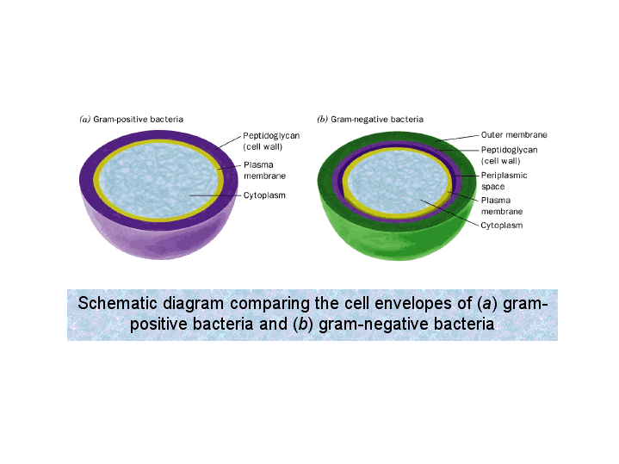

Serianni (2011)

**Extended Spectrum Beta Lactamase**

These are enzymes that will open the beta – lactam ring on anti-biotics and can alter the characteristics of bacteria, making it behave more like a virus with a very flexible DNA; this means that anti-biotic use has become futile.

In the box below, please write an example of an ESBL

**Viruses**

Viruses are smaller than bacteria, and sometimes not classed as cells in their own right. They are organisms that are essentially a strand of DNA with a protective layer that invades host cells overrides the host cell DNA and changes it to its own, this survival mechanism means that a virus can mutate extremely quickly. A successful virus is often not a deadly virus, but one that can co-exist within its host for a long period of time. However, because of the changing nature of viruses, they spread rapidly and can be fatal. The human body can fight a virus with RNA, if it has been previously exposed to the virus in question.

In the box below, please write an example of a virus

**Fungi**

Fungi are single or multi-celled organisms that again, do come in varying shapes. They are primitive forms and exist in all walks of life. Due to their longevity, and evolution the human body is generally effective at combating fungal infections, unless there is a reduction in the body’s immunity.

In the box below, please write an example of a fungus

All microorganisms can be problematic if they become pathogenic, that is, they are existing where they shouldn’t be. This is because if they are surviving it is because they are stronger or more effective than the pre-existing cell/tissue and therefore can inhabit the original matter, taking the oxygen and nutrients that the original cell/tissue required, thus leading to cell dysfunction or cell death. Some pathogens will also release toxic substances to increase surrounding cell death. There is also a build-up of wasted cells (pus/exudate) which can cause surrounding tissue damage.

**Inflammation and the Immune Response**

When there is tissue damage, the body responds with the inflammatory process, which includes ‘redness, heat, pain and swelling’. There is an anatomical reason why this happens. The immediate surrounding blood vessel dilates to allow increased blood flow to the injured area, this gets oxygen and nutrient rich blood to the damaged tissues, and it also gets a variety of white cells to the injured area, where they can fight infection or phagocytise cell debris. The endothelial lining of the vessel then separates allowing for the movement of the white cells, nutrients and oxygen to get to the point of injury. This increased blood flow causes the redness, the increased activity causes the heat, the ‘leaking’ of fluids into the tissues causes the swelling and the swelling very often, will press on nerve endings causing the pain.

This process is life-preserving and will start with the injury or insult, be it a bang on a limb or the rhino-virus with its invading bacteria into the nasal passages, the area becomes inflamed until the area is bacteria or injury free. However, when this process cannot happen or becomes distorted (as in the case of Sepsis) this can become problematic.

**Pathophysiology of Inflammation**

**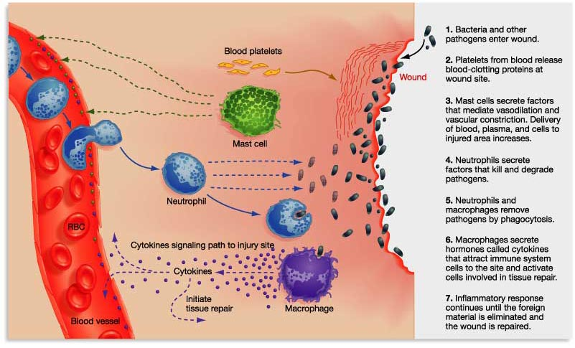**

Semmelweis (2016)

**Infection Control**

When it is understood what microbe is causing what harm, effective treatment can hopefully be prescribed. However, the challenge within healthcare today is to prevent infection spreading.

**Microbiology, Infection Control and Prevention – Review Questions**

What are bacteria?

Name two types of bacteria?

Name two types of bacterial infection?

What is a virus?

Name a viral infection?

What is an ESBL?

Why are ESBLs especially problematic?

What are the ‘four pillars of inflammation’?

What is the difference between inflammation and sepsis?

What can the medico-nursing professions do to reduce infection?

**References to images**

Serianni, A.S. (2011). Schematic diagram comparing cell envelopes of bacteria

<https://www3.nd.edu/~aseriann/CHAP11B.html/sld035.htm>

Semmelweis. (2016) Pathophysiology of Inflammation

http:/semmelweis.hu/oralbiologia/files/2016/02/2016\_Pathophysiology-of-inflammation.pdf

**Bibliography**

Morton Gonce, P., and Fontaine, D.E. (2009) *Critical Care Nursing: A Holistic Approach.* *Ninth* *Edition*; Lippincott Williams and Wilkins: Philadelphia, USA

Walsh, M. and Crumbie, A. (Eds). (2007) *Watson’s Clinical Nursing and Related Science.*  Bailliere Tindall Publishing: London